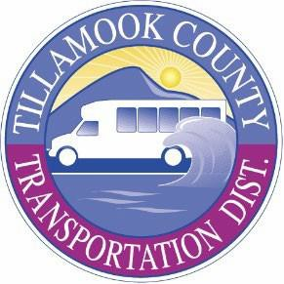

Tillamook County Transportation District PUBLIC MEETING NOTICE
Meetings are held at the Transportation Building located at 3600 Third Street, Tillamook unless otherwise indicated. Persons requiring physical or visual accommodation or who would like a copy of the meeting agenda may contact the District office at (503) 815-8283 before noon, meeting day. Agendas are also available on the District website at https://www.nwconnector.org/tillamook-transportation-board-meetings/

Participants are welcome to join this meeting virtually.
To attend by phone, please dial: +1 (253) 215-8782 Meeting ID: 880 8898 5392 To attend virtually, please use this link: https://us02web.zoom.us/j/88088985392

Wednesday, February 18, 2026, @ 6:00pm

Board of Directors Regular Monthly Meeting
Agenda items will include a State of the District Report with information regarding District finances and grants, service performance, the Northwest Oregon Transit Alliance, the NW Rides NEMT Brokerage, and General Manager activities. The agenda also includes Consent, Action, and Discussion Items with Staff and Board of Director comments. An Executive Session will be added as needed.

