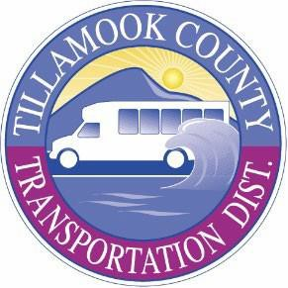

Tillamook County Transportation District PUBLIC MEETING NOTICE
Meetings are held at the Transportation Building located at 3600 Third Street, Tillamook unless otherwise indicated. Persons requiring physical or visual accommodation or who would like a copy of the meeting agenda may contact the District office at (503) 815-8283 before noon, meeting day. Agendas are also available on the District website at https://www.nwconnector.org/tillamook-transportation-board-meetings/

Participants are welcome to join this meeting virtually.
To attend by phone, please dial: +1 (253) 215-8782 Meeting ID: 880 8898 5392 To attend virtually, please use this link: https://us02web.zoom.us/j/88088985392

Wednesday, January 21, 2026, @ 6:00pm

Board of Directors Regular Monthly Meeting
Agenda items will include General Manager’s Financial, Operational, and Service Reports. The agenda also includes Action & Discussion Items, and Director’s/Staff Comments & Concerns and an Executive Session as needed.

