*Regular f..,[eeting 9/18/2024*

**Tillamook County Transportation District** Board of Directors Regular Monthly Meeting Wednesday, September 18, 2024 - 6:00PM Transportation Building

3600 Third Street, Tillamook, OR

**Meeting Minutes**

1. **Call to Order:** Vice Chair Adler called the meeting to order at 6:00 pm.
2. **Pledge of Allegiance**
3. **Roll Call:**

**Present**

**TCTD Board of Directors** Gary Hanenkrat, Director Marni Johnston, Treasurer Jonathan Bean, Secretary

Thomas Fiorelli, Director (via Zoom) Linda Adler, Vice Chair (via Zoom)

**Absent**

**TCTD Board of Directors**

Mary Johnson, Board Chair

**TCTD Staff**

Brian Vitulli, General Manager (via Zoom)

Cathy Bond, Finance Supervisor/Interim Board Clerk Jules Deputy, Brokerage Manager

Michael Reed, Operations Superintendent Keri Brown, Admin Assistant/Board Clerk

**Guest**

Jeremy Miller, Citizen Jim Hefferman, Citizen

1. **Announcements and Changes to Agenda:** None.
2. **Public & Guest Comments:**

Jeremy Miller asked how performance is measured in the GM report and from page 33 of the Board packet, how is ridership down? GM Vitulli explained that it is presented monthly in the Board packet and described how system performance is measured.

OS Reed stated that the Coordinated Transportation Plan that was presented in May to the Board was assisted by feedback gathered by our consultant using surveys and from feedback from the community.

Jim Hefferman stated that we still don't have enough drivers, which is alarming.

1. **Executive Session:** NONE

*Regular 1\lleeting 9/18/2024*

**STATE OF THE DISTRICT REPORT**

1. **Financial and Grant Report:** FS Bond reviewed the June 2024 financials and fiscal year-end report included in the Board packet pages 1-32.
2. **Service Performance Report:** OS Reed provided service statistics and annual operations performance and analysis measures for the fiscal year July 1, 2023, to June 30, 2024, included in the Board packet pages 33-73.
3. **Northwest Oregon Transit Alliance:** GM Vitulli provided the following updates included in Board packet pages 74-76.
4. **NW Rides Brokerage:** BM Deputy provided the following updates:
   1. NW Rides total trips for July 1, 2023, to June 30, 2024.
   2. NW Rides total miles for July 1, 2023, to June 30, 2024.
   3. NW Rides total trip cost for July 1, 2023, to June 30, 2024.

BM Deputy advised that Narcan was picked up from CARE office in Tillamook so we can provide it to our volunteer drivers.

1. **General Manager Report:** GM Vitulli provided the following updates included in Board packet pages 80 -81 (see GM Report in packet for details):
   1. **Administration/Coordination**
   2. **Planning Development**
   3. **Grant Funding**
   4. **Facility/Property Development**
   5. **Operations and Vehicle Maintenance**
2. **Miscellaneous:** None.

**CONSENT CALENDAR**

1. Motion by Dir. Johnston to Approve the Minutes of August 21, 2024, Regular Board Meeting. Motion Seconded by Dir. Bean.

**Motion Passed**

By Directors Hanenkrat, Bean, Fiorelli, Johnston, and Vice Chair Alder.

1. Motion by Dir. Johnston to Approve June 2024 Financial Statement. Motion Seconded by Dir. Bean.

**Motion Passed**

By Directors Hanenkrat, Bean, Fiorelli Johnston, and Vice Chair Alder.

**ACTION ITEMS**

None

**DISCUSSION ITEMS**

1. **Staff Comments/Concerns:**

*Regular Meeting 9118/2024*

General Manager Vitulli: Thanked the Board for their support. Thanked staff as well; for their hard work is the reason for the success of the District.

Operations Superintendent Reed: The District has a new driver moving up to a dispatcher position, and training will be four to six weeks. Thanked the Board of Directors for patience in getting remaining items completed at the Transit Center.

1. **Board of Directors Comments/Concerns:**

Dir. Adler asked about the completion of the Transit Center and when it will be open to the public. GM Vitulli stated that we are still trying to hire and train another dispatcher to work at the Transit Center before keeping it open during regular hours.

Dir. Hanenkrat said that he heard on the scanner about the local police picking up people and transporting them to the Transit Center at odd hours of the night. Why would the police be dropping people off when the Transit Center is closed. OS Reed said that some people camp out waiting for the bus to go to Portland or wherever and they have no where else to go.

Dir. Hanenkrat asked about the GM report under **Administration/Coordination.** It states, "Meeting with counsel to discuss various District issues." GM Vitulli said that staff regularly meets with different attorneys to discuss issues related to managing the District.

Dir. Johnston is excited about restoring Sunday services.

Dir. Fiorelli thanked FS Bond for the stellar details in the Financial and Grant Report and was very impressed.

Dir. Adler was excited about Sunday's being restored.

Dir. Adler asked about the Public Meeting Law training for the Board of Directors. GM Vitulli said that he will get information out to everyone with instructions on how to accomplish that.

Adjournment: Board Vice Chair Adler adjourned the meeting at 6:52 pm.

**These minutes approved this 18th of September 2024.**

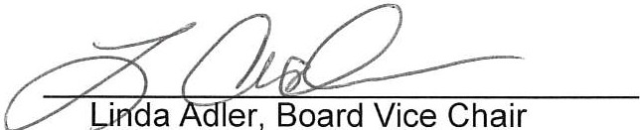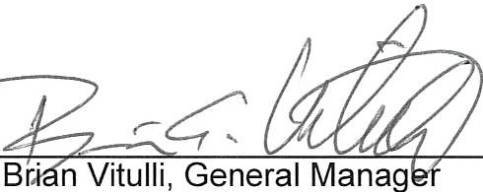ATTEST: