
Regular Avleeting 9/18/2024
Tillamook County Transportation District
Board of Directors Regular Monthly Meeting
Wednesday, September 18, 2024 - 6:00PM
Transportation Building
3600 Third Street, Tillamook, OR
Meeting Minutes
1. Call to Order: Vice Chair Adler called the meeting to order at 6:00 pm.
2. Pledge of Allegiance
3 Roll Call:
Present
TCTD Board of Directors
Gary Hanenkrat, Director
Marni Johnston, Treasurer
Jonathan Bean, Secretary
Thomas Fiorelli, Director (via Zoom)
Linda Adler, Vice Chair (via Zoom)
Absent
TCTD Board of Directors
Mary Johnson, Board Chair
TCTD Staff
Brian Vitulli, General Manager (via Zoom)
Cathy Bond, Finance Supervisor/Interim Board Clerk
Jules Deputy, Brokerage Manager
Michael Reed, Operations Superintendent
Keri Brown, Admin AssistanUBoard Clerk
Guest
Jeremy Miller, Citizen
Jim Hefferman, Citizen
4. Announcements and Changes to Agenda: None.
5. Public & Guest Comments:
Jeremy Miller asked how performance is measured in the GM report and from page
33 of the Board packet, how is ridership down? GM Vitulli explained that it is presented
monthly in the Board packet and described how system performance is measured.
OS Reed stated that the Coordinated Transportation Plan that was presented in May
to the Board was assisted by feedback gathered by our consultant using surveys and
from feedback from the community.
Jim Hefferman stated that we still don't have enough drivers, which is alarming.
6. Executive Session: NONE
These mrnutes contain materials svhich paraphrase and/or sunmiarrze statements made during thrs meeting. Only text enclosed m quotation
marks report a speaker as exact svords.

Regular Aileeting 9/18/2024
STATE OF THE DISTRICT REPORT
7. Financial and Grant Report: FS Bond reviewed the June 2024 financials and fiscal
year-end report included in the Board packet pages 1-32.
8. Service Performance Report: OS Reed provided service statistics and annual
operations performance and analysis measures for the fiscal year July 1, 2023, to
June 30, 2024, included in the Board packet pages 33-73.
9. Northwest Oregon Transit Alliance: GM Vitulli provided the following updates
included in Board packet pages 74-76.
10. NW Rides Brokerage: BM Deputy provided the following updates:
a. NW Rides total trips for July 1, 2023, to June 30, 2024.
b. NW Rides total miles for July 1, 2023, to June 30, 2024.
c. NW Rides total trip cost for July 1, 2023, to June 30, 2024.
BM Deputy advised that Narcan was picked up from CARE office in Tillamook so we
can provide it to our volunteer drivers.
l1.General Manager Report: GM Vitulli provided the following updates included in
Board packet pages 80 -81 (see GM Report in packet for details):
a. Administration/Coordination
b. Planning Development
c. Grant Funding
d. Facility/Property Development
e. Operations and Vehicle Maintenance
12.Miscellaneous: None.
CONSENT CALENDAR
13. Motion by Dir. Johnston to Approve the Minutes of August 21, 2024, Regular Board
Meeting. Motion Seconded by Dir. Bean.
Motion Passed
By Directors Hanenkrat, Bean, Fiorelli,
Johnston, and Vice Chair Alder.
14. Motion by Dir. Johnston to Approve June 2024 Financial Statement. Motion
Seconded by Dir. Bean.
Motion Passed
By Directors Hanenkrat, Bean, Fiorelli
Johnston, and Vice Chair Alder.
ACTION ITEMS
None
DISCUSSION ITEMS
15. Staff Comments/Concerns:
These minutes contam nyaterrals svhrch paraphrase and/or summarize statements made durrng, this meeting. Only text enclosed m quotatron
marks report a speaker's exact words.

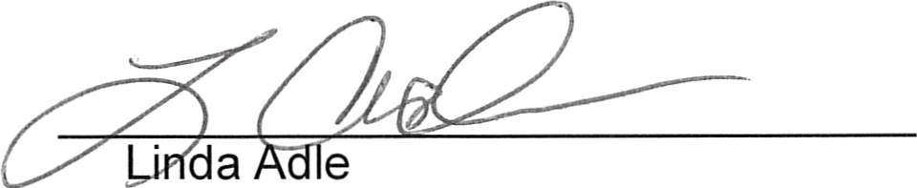
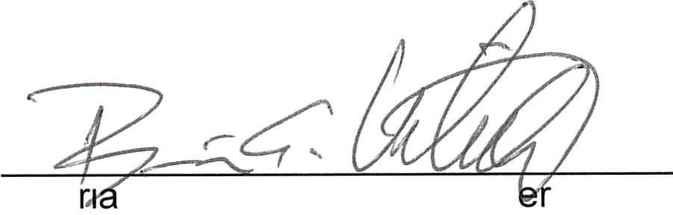
Regular Meeting 9/18/2024
General Manager Vitulli: Thanked the Board for their support. Thanked staff as well;
for their hard work is the reason for the success of the District.
Operations Superintendent Reed: The District has a new driver moving up to a
dispatcher position, and training will be four to six weeks. Thanked the Board of
Directors for patience in getting remaining items completed at the Transit Center.
l6.Board of Directors Comments/Concerns:
Dir. Adler asked about the completion of the Transit Center and when it will be open
to the public. GM Vitulli stated that we are still trying to hire and train another
dispatcher to work at the Transit Center before keeping it open during regular hours.
Dir. Hanenkrat said that he heard on the scanner about the local police picking up
people and transporting them to the Transit Center at odd hours of the night. Why
would the police be dropping people off when the Transit Center is closed. OS Reed
said that some people camp out waiting for the bus to go to Portland or wherever and
they have no where else to go.
Dir. Hanenkrat asked about the GM report under Administration/Coordination. It
states, "Meeting with counsel to discuss various District issues." GM Vitulli said that
staff regularly meets with different attorneysto discuss issues related to managing the
District.
Dir. Johnston is excited about restoring Sunday services.
Dir. Fiorelli thanked FS Bond for the stellar details in the Financial and Grant Report
and was very impressed.
Dir. Adler was excited about Sunday's being restored.
Dir. Adler asked about the Public Meeting Law training for the Board of Directors. GM
Vitulli said that he will get information out to everyone with instructions on how to
accomplish that.
Adjournment: Board Vice Chair Adler adjourned the meeting at 6:52 pm.
These minutes approved this I 8'h of September 2024.
ATTEST:
r, Board Vice Chair
B a n Vitulli, General Manag
These minutes contain materials svhrch paraphrase and/or summarize statements made during thrs meeting. Only text enclosed in quotatron
marks report a speaker's exact words.

