SUNSET EMPIRE TRANSPORTATION DISTRICT
CONGRATULATES
Alejandro Palacious-Hernandez
EMPLOYEE OF THE QUARTER
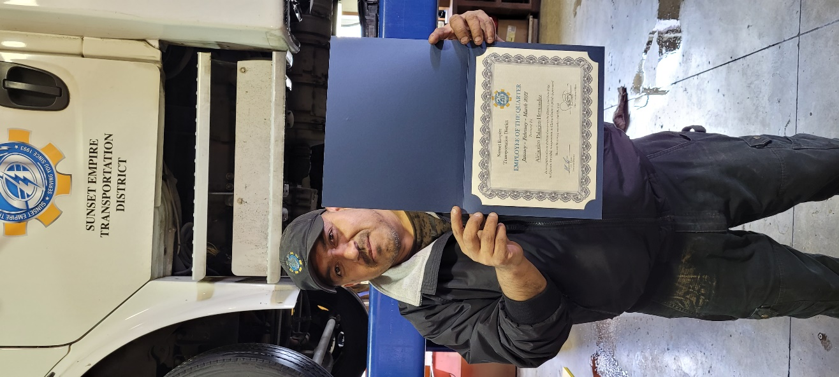
Sunset Empire Transportation District’s Management Team has selected Alejandro (Alex) Palacious- Hernandez as Employee of the First Quarter of 2022. Alex was presented with a certificate and gift during the April 29, 2022, all staff meeting. Alex started working for SETD August 13, 2021, as the Assistant Mechanic. He was then promoted to the Mechanic position on October 20, 2021. Alex is responsible for maintaining all the district buses, vehicles, office buildings, shop, bus shelters and reporting the ongoing status of these to the Maintenance Supervisor. While working, Alex has also continued to study and train for his CDL B License which he passed on February 14, 2022.
Alex has many job duties and is a very hard worker He is known for his reliability and helping wherever he can. Alex goes above and beyond in everything he does and always greets everyone with a smile. Alex is a great asset to SETD.
When not working at SETD, Alex enjoys spending time with his family.

Congratulations and thank you for all you do Alex!

