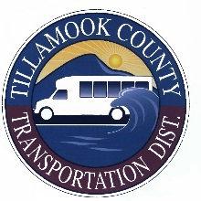
NOTICE OF BUDGET COMMITTEE MEETING

A public meeting of the Budget Committee of the Tillamook County Transportation District (TCTD), Tillamook County, State of Oregon, to discuss the budget for the fiscal year July 1, 2022 to June 30, 2023 will be held at the Tillamook County Transportation District at 3600 Third Street, Suite A, Tillamook, Oregon. The meeting will take place on Tuesday, May 10, 2022 at 6:00pm. The purpose of the meeting is to receive the budget message and to receive comment from the public on the budget. A copy of the budget document may be inspected or obtained at TCTD at 3600 Third Street, Suite A, Tillamook, Oregon, between the hours of 8:00am and 5:00pm, Monday through Friday. This is a public meeting where deliberation of the Budget Committee will take place. Any person may appear at the meeting and discuss the proposed programs with the Budget Committee. Anyone needing visual or physical accommodations is asked to call the TCTD offices at 503-815-8283. The meeting will be available to attend virtually. To attend by phone, please dial: +1 253 215 8782. Meeting ID: 874 2859 1025. Meeting Link: https://us02web.zoom.us/j/87428591025 Please go to https://www.nworegontransit.org/tillamook-transportation-board-meetings/ for the most up-to-date information regarding this meeting.

