Sunset Empire Transportation District
BOARD OF COMMISSIONERS
TELEPHONIC BOARD MEETING AGENDA
THURSDAY APRIL 23, 2020
9:00 AM
Astoria Transit Center, 900 Marine Drive Astoria, OR

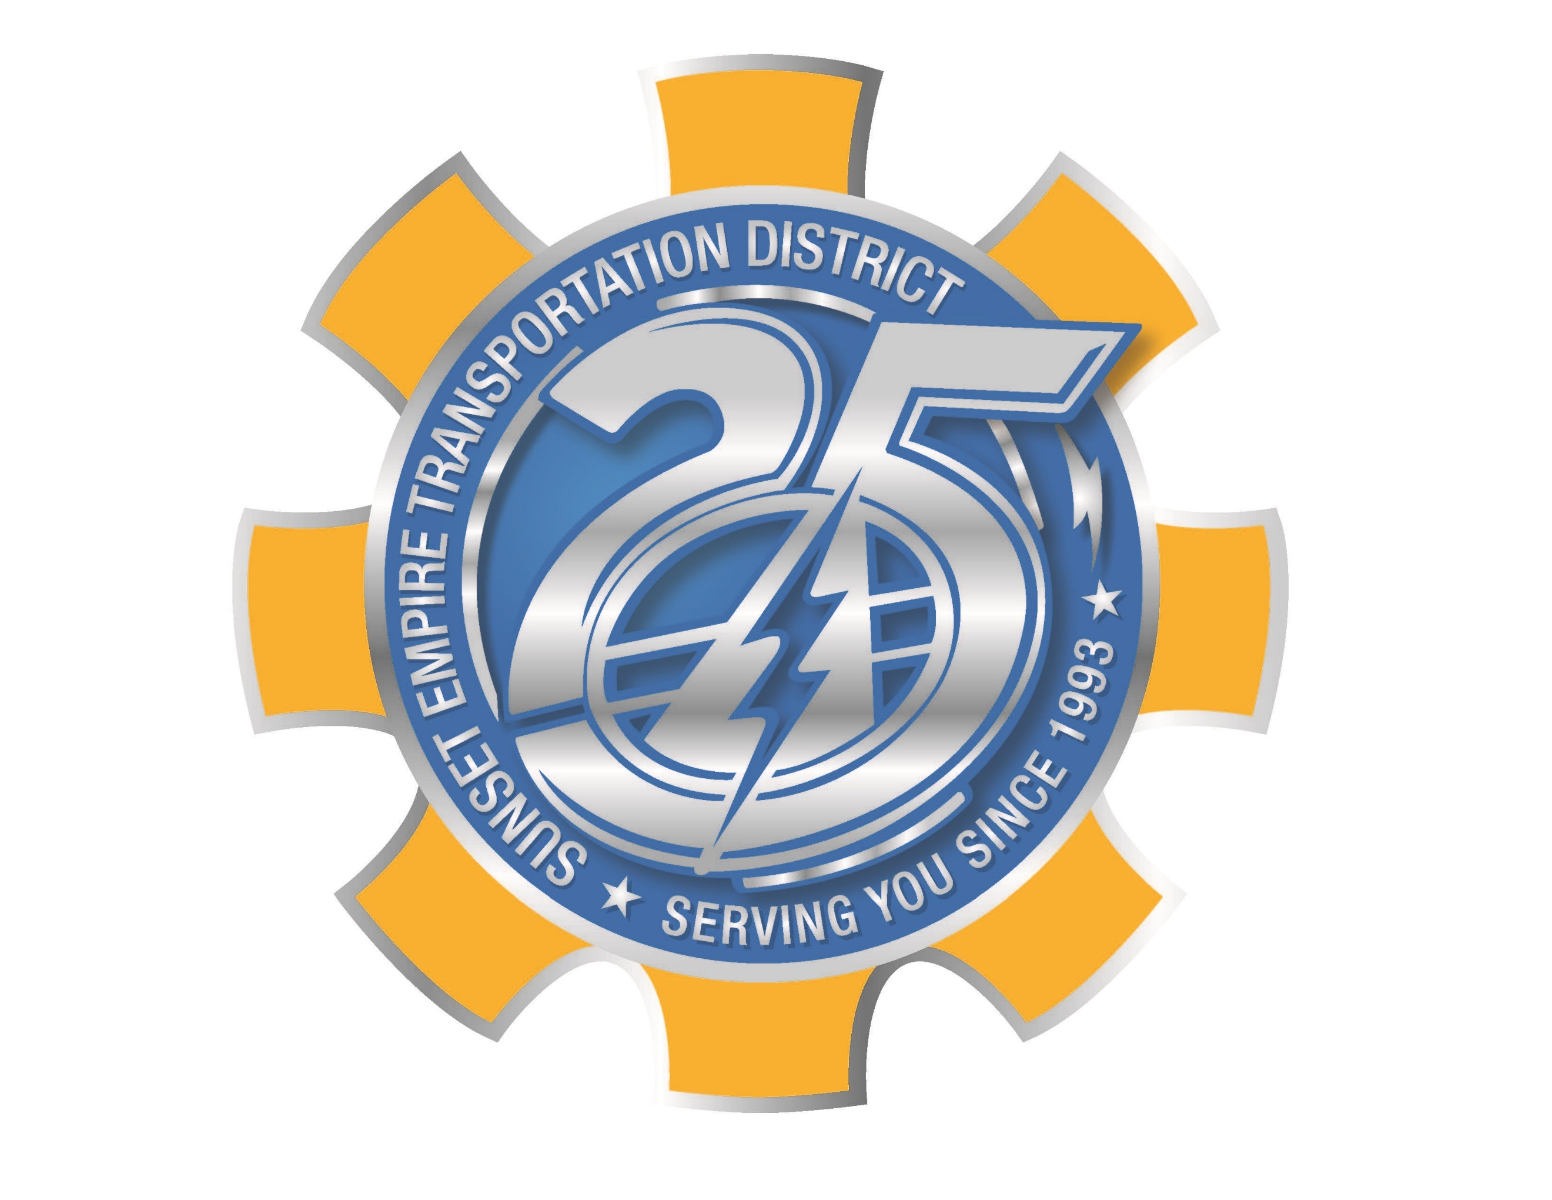

Call in numbers:
888-853-5247 or 888-788-0099
Meeting ID 912 3219 3434

AGENDA:
- CALL TO ORDER; PLEDGE OF ALLEGIANCE
- ROLL CALL
- CHANGES TO AGENDA
- PUBLIC COMMENT (3-minute limit) Please email jeff@ridethebus.org by April 22nd at 5:00. All comments will be read into the record.
- APPROVAL OF BOARD MEETING MINUTES
- REPORTS FROM CHAIR AND COMMISSIONERS
- FINANCIAL REPORTS
- OLD BUSINESS
  - Ordinance 2020-01 Second Reading and Adoption
- NEW BUSINESS
  - Compliance Review Final Report
  - Grant Letter of Affirmation
  - Procurement Policy Adoption
  - RLS & Associates Agreement Approval
  - Shelter Procurement
  - Executive Director Vacation Carryover Request
  - Executive Director Performance Evaluation
- CORRESPONDENCE
- EXECUTIVE DIRECTOR REPORT
- LEADERSHIP TEAM REPORTS
- OTHER ACTIONS

