Sunset Empire Transportation District
Coordinated Human Services
Public Transportation Plan
“Coordinated Plan”

November, 2007
Updated Draft: January 26, 2011
Approved Update: January 27, 2011
Updated Draft January 28, 2015
Approved Update

Introduction
The aim of this Coordinated Plan is to improve transportation services for individuals with disabilities, individuals who are senior, and individuals with lower incomes by providing strategies to guide the investment of available funds and guide the acquisition of future grants. This section of the plan focuses on the specialized needs of low income families, the elderly, and people with disabilities. While always an integral component of SETD, the District has had an added emphasis on addressing the transportation needs of these special populations over the last six years. Significant progress has been made. This plan addresses coordination of resources and services so as to minimize duplication of effort enhance services and encourage the most cost-effective transportation feasible. The plan also considers, to the maximum extent feasible, other similar plans in the regional area, resulting in regional opportunities to coordinate services.

This Coordinated Plan summarizes stakeholder research and priorities, based on demographic and survey research and meetings with transportation providers, community agencies and medical services providers. The Plan also includes an evaluation of community resources and assessment of targeted population transportation needs.

An addition to the Coordinated Plan is the Medicaid Integrated Grant (MIG) Project Plan, found on page 37. The primary goal of the MIG project was to engage the community planning process to specifically evaluate the current status and future opportunities for transportation supporting access to work for people with disabilities.

Table of Contents

 | Page
Evaluation of Community Resources  - Profile—Clatsop County Low Income, Seniors, People with Disabilities  - Transportation Resources Available to Clatsop County Low Income, Seniors, People with Disabilities | 4
Assessment of Transportation Needs for People with Low Incomes, Seniors and People with Disabilities | 18
Strategies/Activities Addressing the Identified Gaps and Efficiencies in Service Delivery through Coordination | 27
Relative Priorities of Strategies  - FY 11/13 Grant Requests  - Opportunities for Future Collaboration | 31
Stakeholder Involvement | 36
MIG Project Plan | 37
Appendix  - Public Meetings and Meeting Minutes | 43

Evaluation of Community Resources

An accurate evaluation of the transportation resources available to the low income, senior and disabled residents in Clatsop County requires profiles of both these special needs populations and the transportation resources available to them. The special needs populations in Clatsop County represent about 44% of the total residents.

Profile—Clatsop County Low Income, Senior and Disabled Residents

County Income/Low Income
In 2013, Clatsop had a per capita personal income (PCPI) of $37,989. This PCPI ranked 11th in the state and was 95 percent of the state average, $39,848, and 85 percent of the national average, $44,765. The 2013 PCPI reflected an increase of 2.7 percent from 2012. The 2012-2013 state change was 1.5 percent and the national change was 1.3 percent. In 2003, the PCPI of Clatsop was $28,508 and ranked 7th in the state. The 2003-2013 compound annual growth rate of PCPI was 2.9 percent. The compound annual growth rate for the state was 2.8 percent and for the nation was 3.2 percent.
It is estimated that 6,118 people in Clatsop County are living below the poverty line. That is 16.7% of the residents. That is higher than the average of Oregon – 16.5% and the United States – 15.8%

Basic Family Budget
According to a US Department of Agriculture report, between 2011 and 2013, 15.2% of Oregon households struggled to meet their basic food needs. This is up 11% from 2008-10 of 13.7 percent.
The following chart outlines typical expenses for four family types in Clatsop County and the corresponding income those families would need to meet their expenses.
Clatsop County’s basic family budget:
Basic family budget/month | 1 adult and  1 child | 1 adult and  3 children | 2 adults and  1 child | 2 adults and  3 children
Housing | $684 | $952 | $684 | $952
Food | $369 | $735 | $510 | $1,219
Child care | $510 | $1,219 | $510 | $1,219
Transportation | $570 | $570 | $717 | $717
Health care | $980 | $1,455 | $328 | $480
Other necessities | $269 | $432 | $328 | $480
Taxes | $289 | $87 | $171 | $308
Basic family budget needed/month | $3,671 | $5,450 | 4,376 | $6,126
Basic family budget total/annual | $44,052 | $65,400 | $52,512 | $73,512
Hourly wage needed for basic family budget | $21.18 | $31.44 | $25.25 | $35.34
Poverty threshold | 15,730 | $23,850 | $19,790 | $27,910
% Of basic budget | 35.7% | 36.5% | 37.7% | 38.0%
% Transportation of Budget | 12.9% | 8.7% | 13.7% | 9.8%
(Data from Economic Policy Institute – Family Budget Calculator – Updated 2013)
Seniors
Residents over 65 years of age account for 15.8% of Clatsop County’s population, above the State-wide average of 13.1%. Clatsop County’s senior population is expected to increase to 22% of the population in 2020 and by 2030, 26% residents are projected to be 65 years or older. The highest concentration of seniors currently live in Cannon Beach (20% of population), followed by Gearhart (18%), Astoria, (17%), Seaside (17%) and Warrenton (14%). (See Seniors Census Map and Clatsop County Community in Focus)
People with Disabilities
Clatsop residents with disabilities tend to live close to population centers. The highest concentrations are found in Seaside (21% of population) and Astoria (16% of population). Between the ages of 18 and 64, approximately 16.3% of Clatsop County’s residents are disabled, above the State-wide average of 11.7%. Populations above the age of 65 who have a disability in Clatsop County are 37.1% of the population, close to the State-wide average of 37.7%. (U.S. Census Bureau – 2009-2013 5-Year American Community Survey).
Veterans
Veterans are included in this profile of special needs populations because of the travel distance for medical services, typically to the VA in Portland. While not all veterans require public or assisted transportation, segments of this population have special needs. 13.4% of Clatsop County’s residents are civilian veterans, which is greater than the state average of 10.3%. The highest concentration of veterans living south of Astoria in the Miles Crossing/Jeffers Garden/Youngs River Loop area. (See Civilian Veterans Census Map)

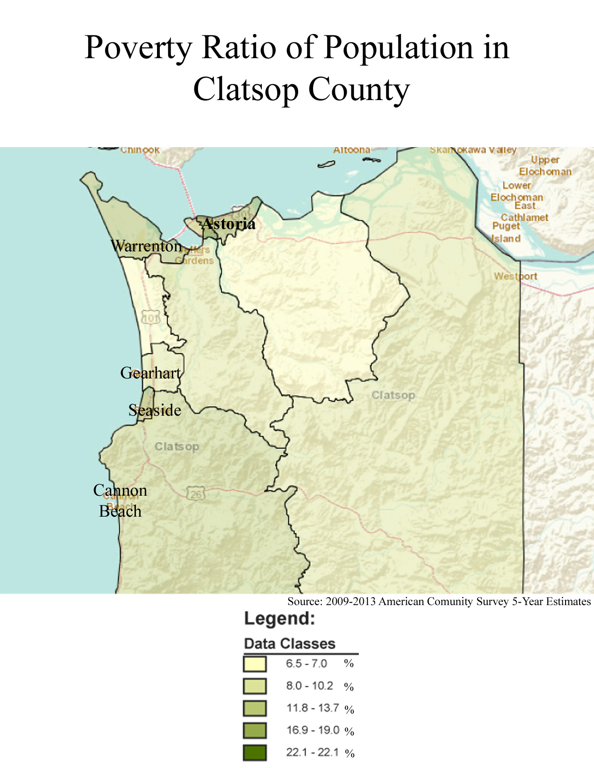
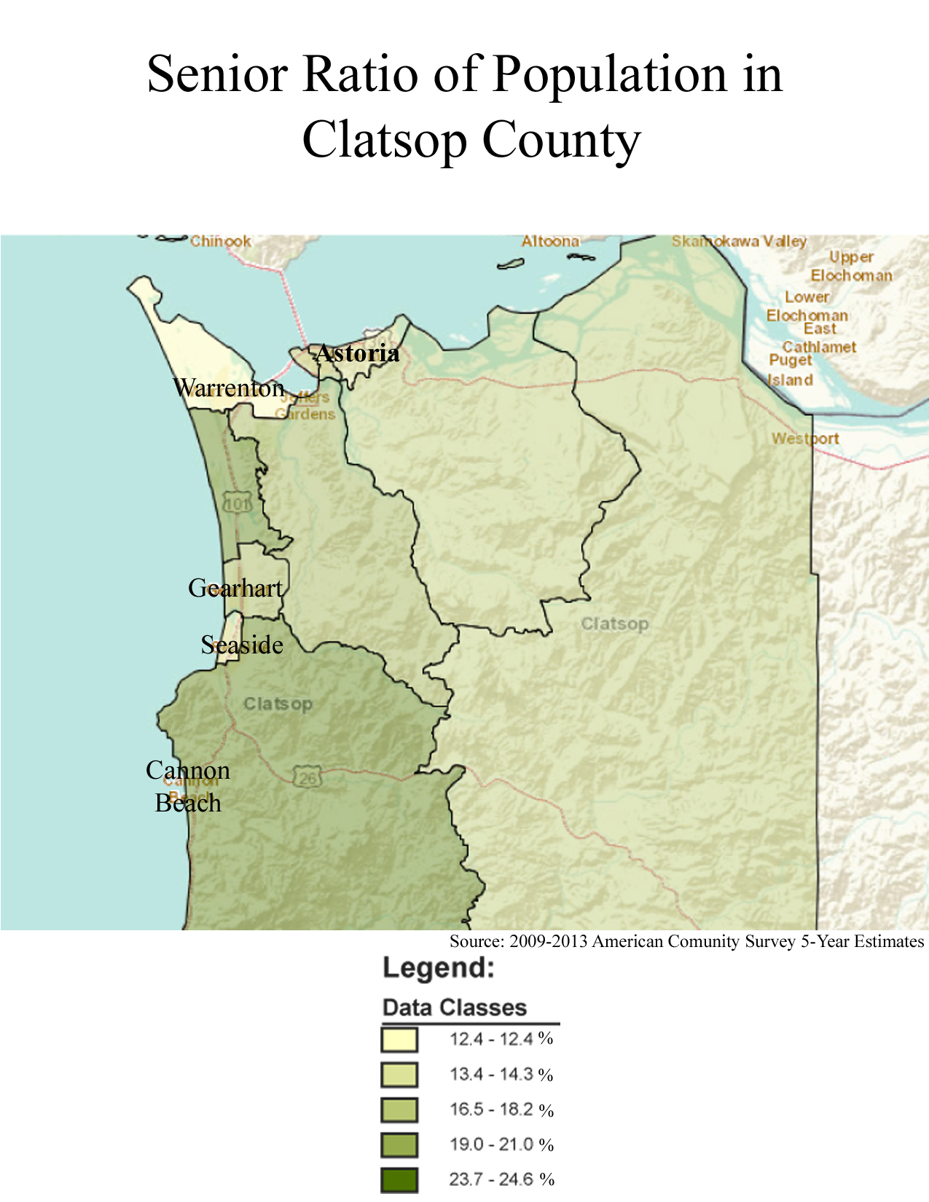

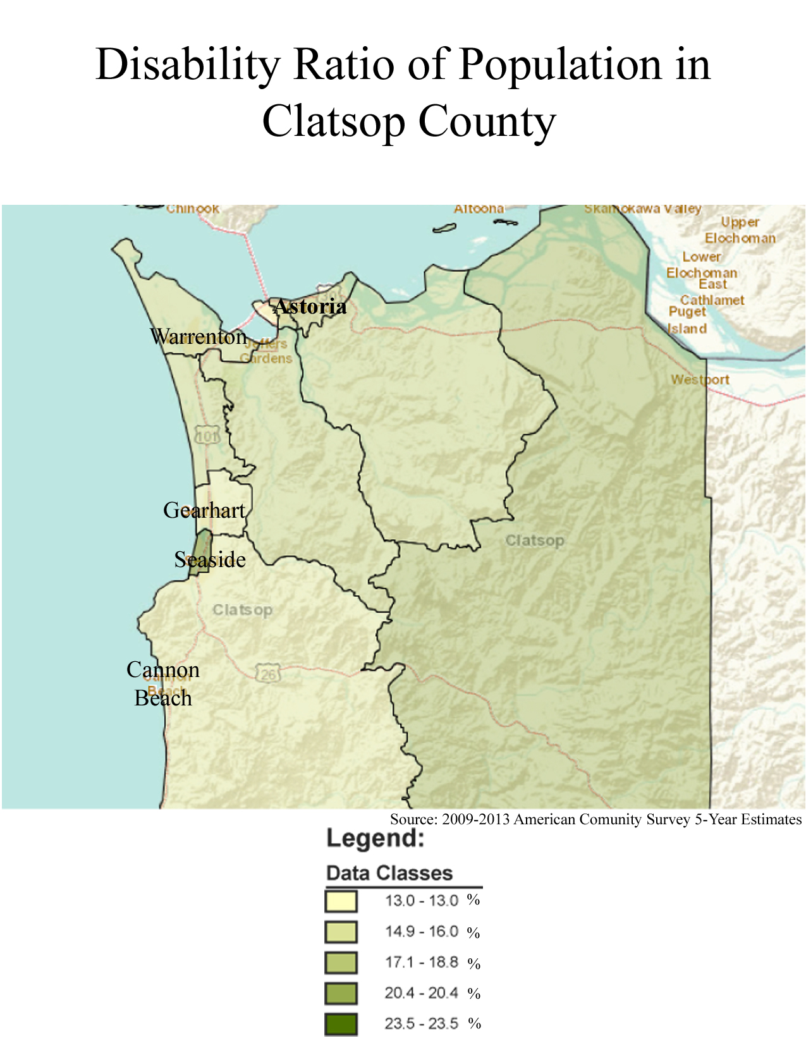

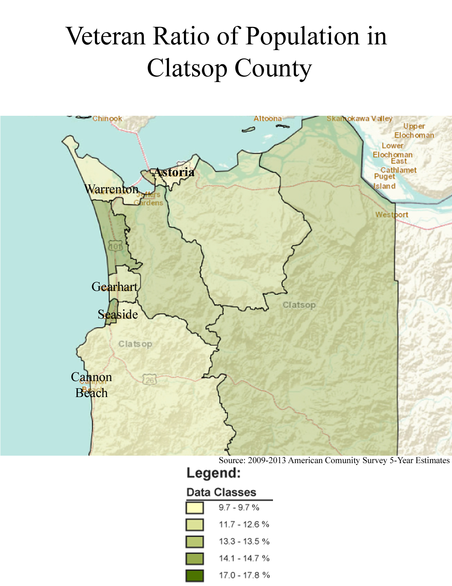
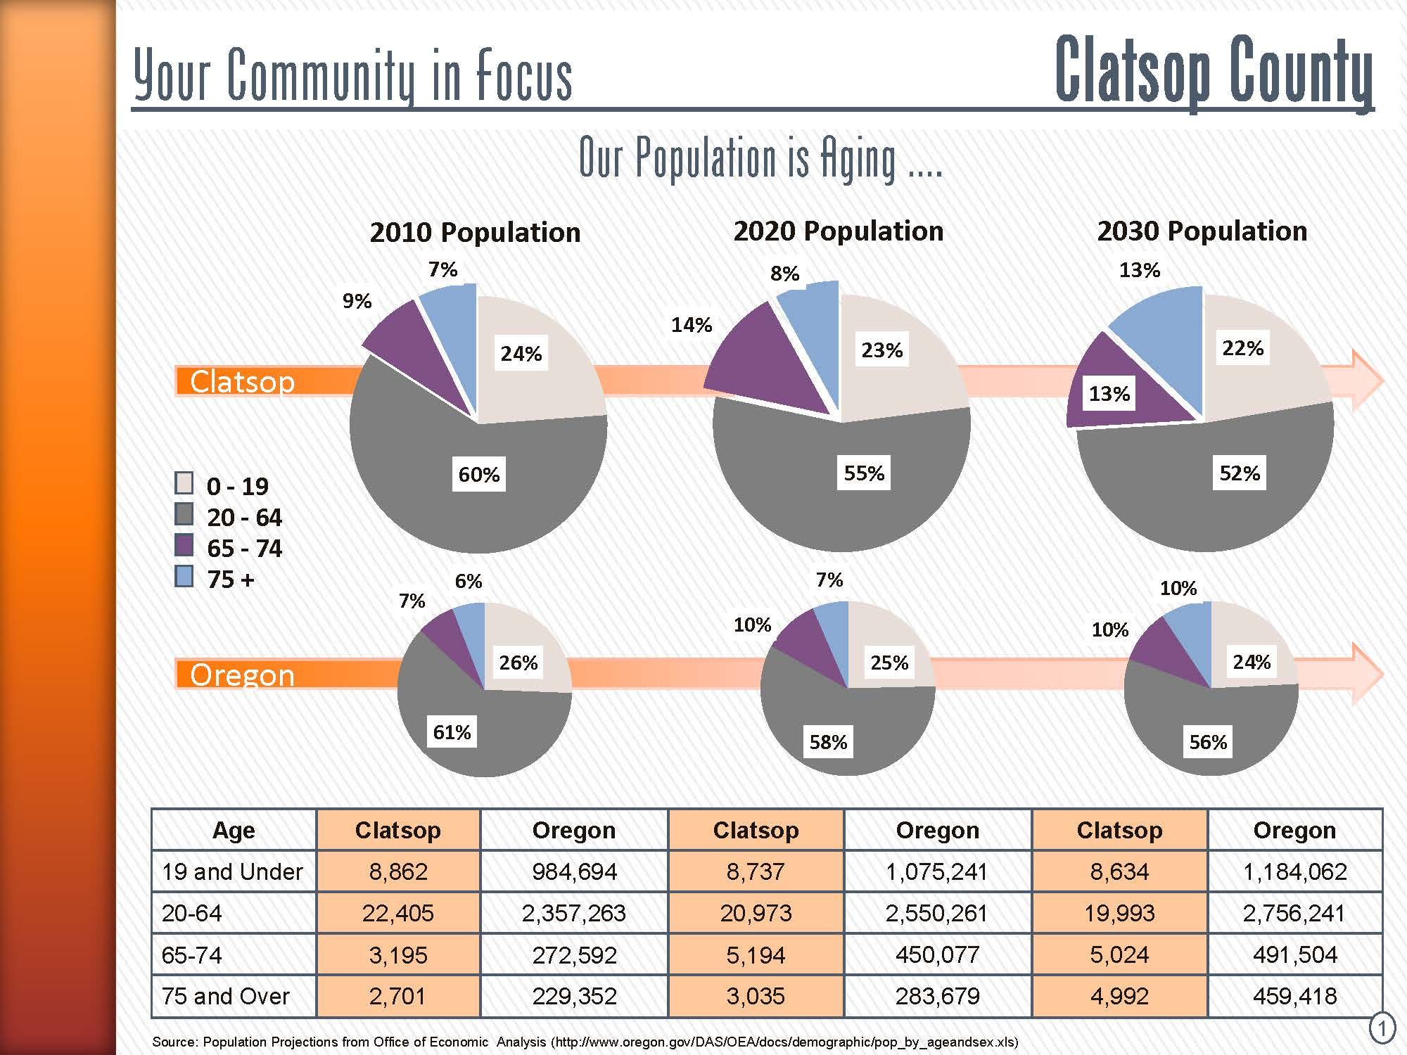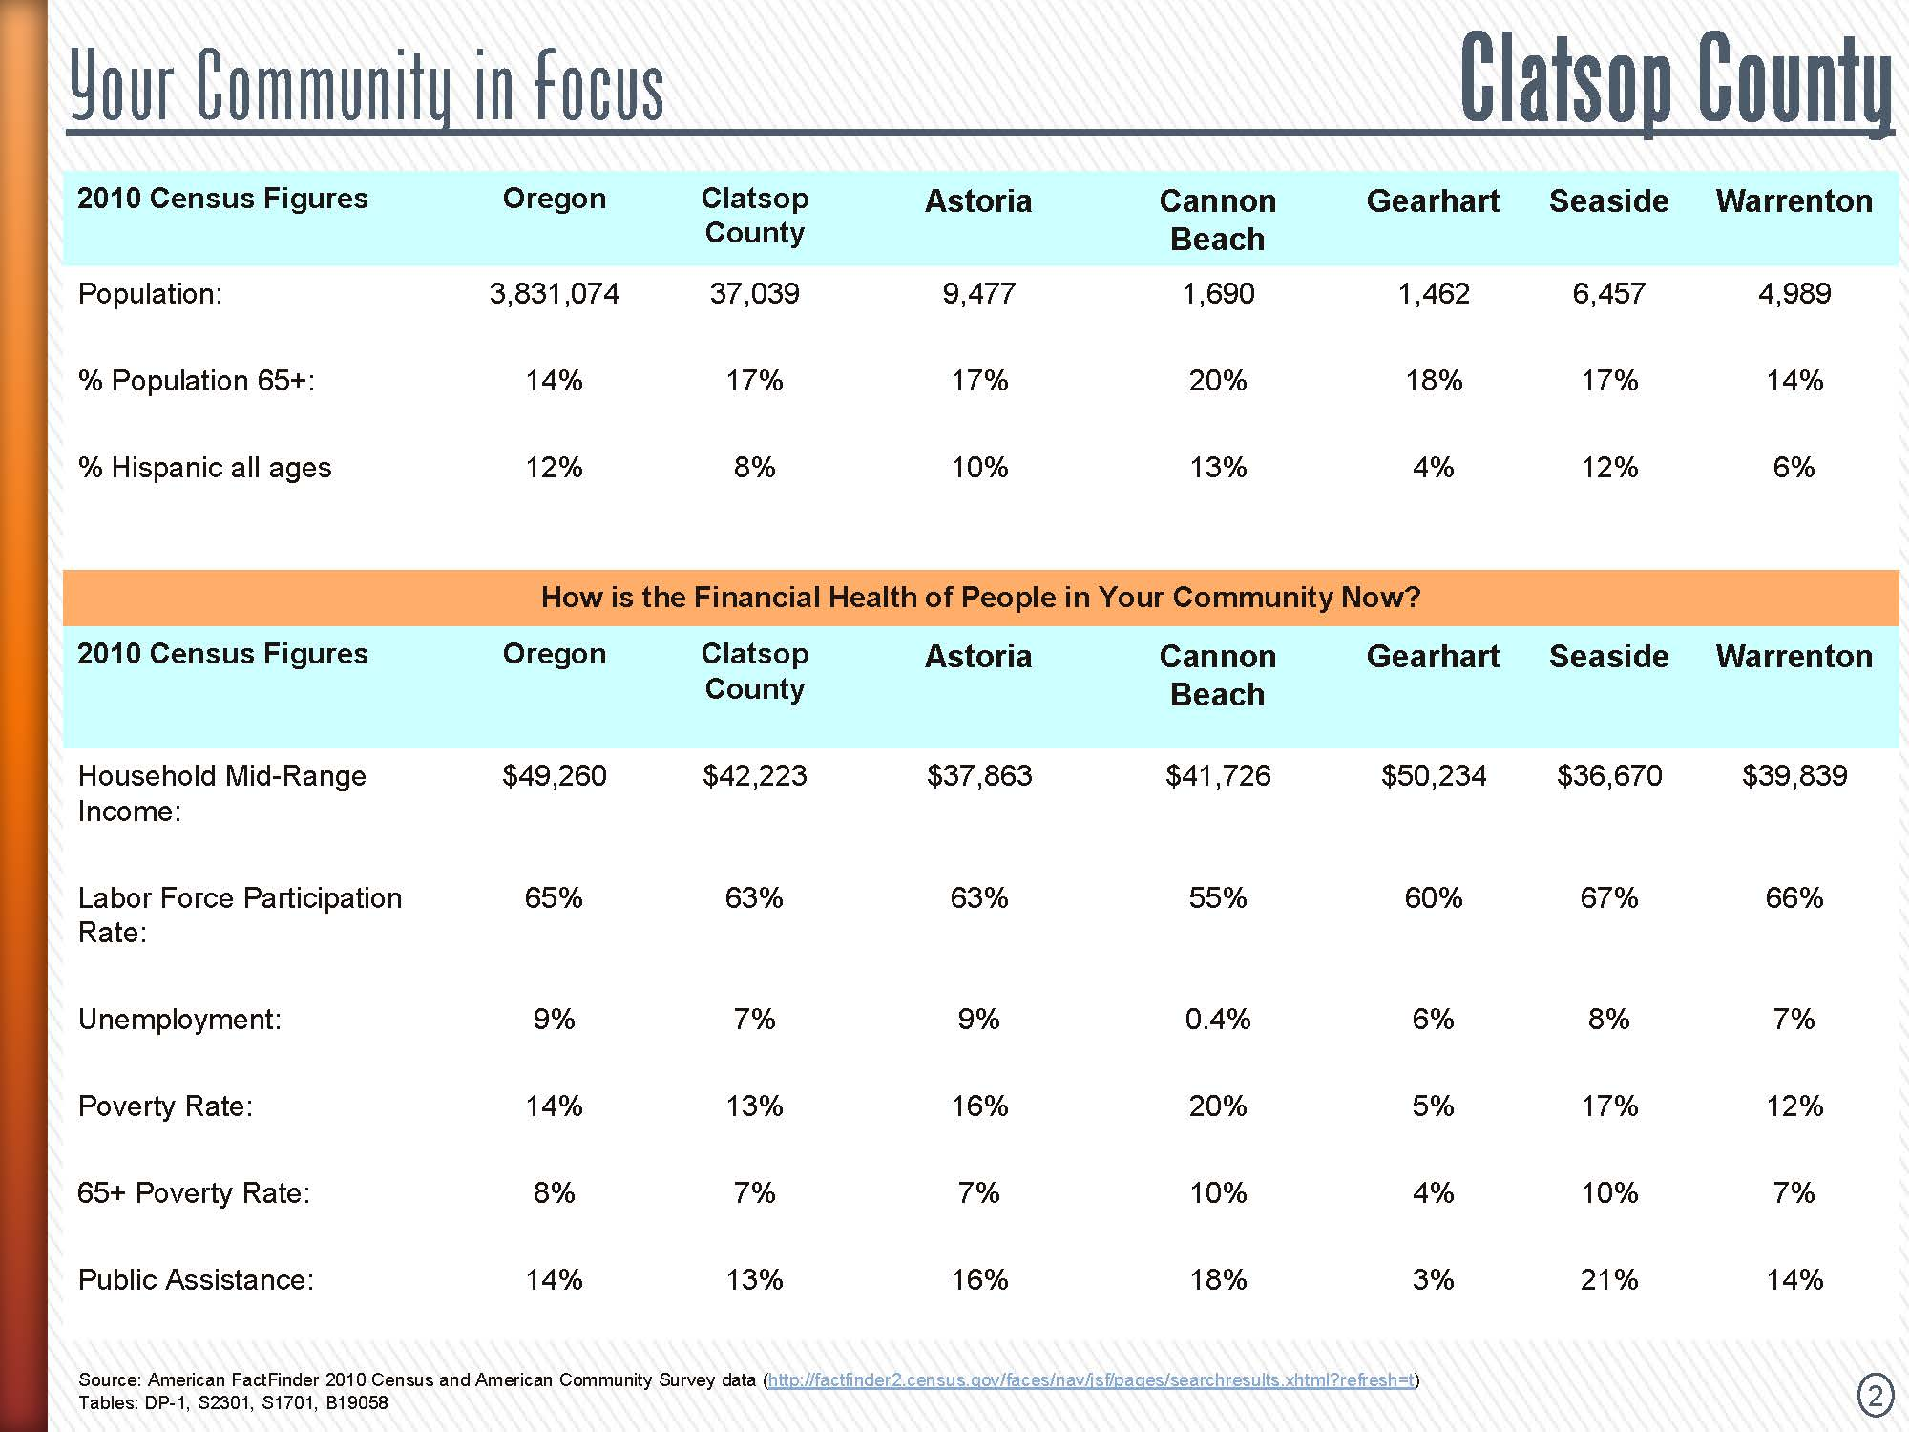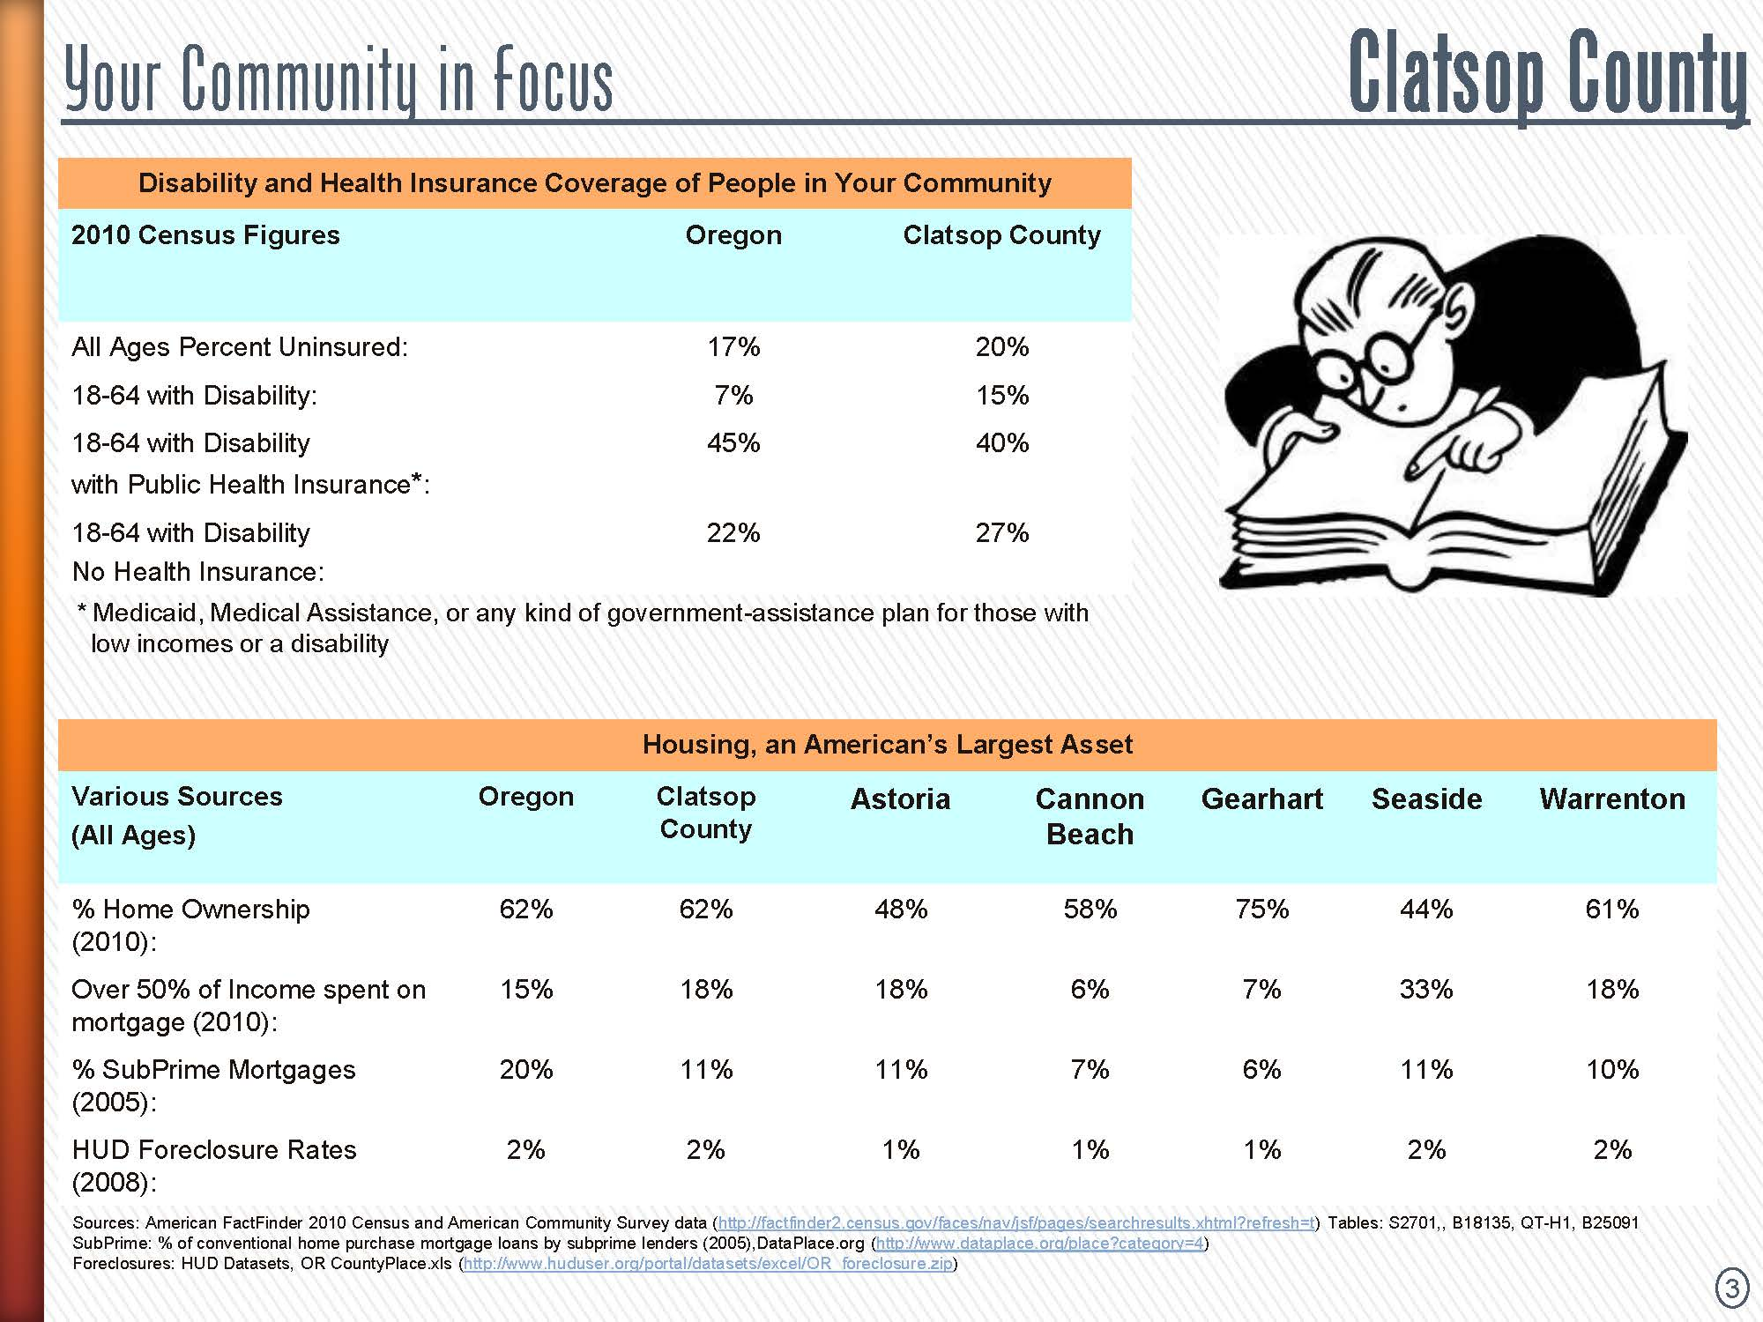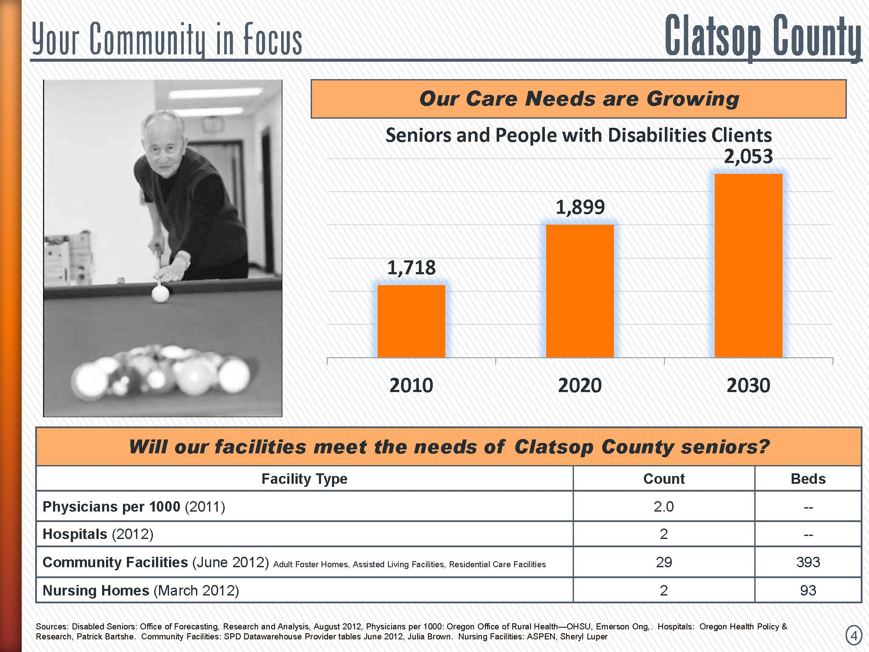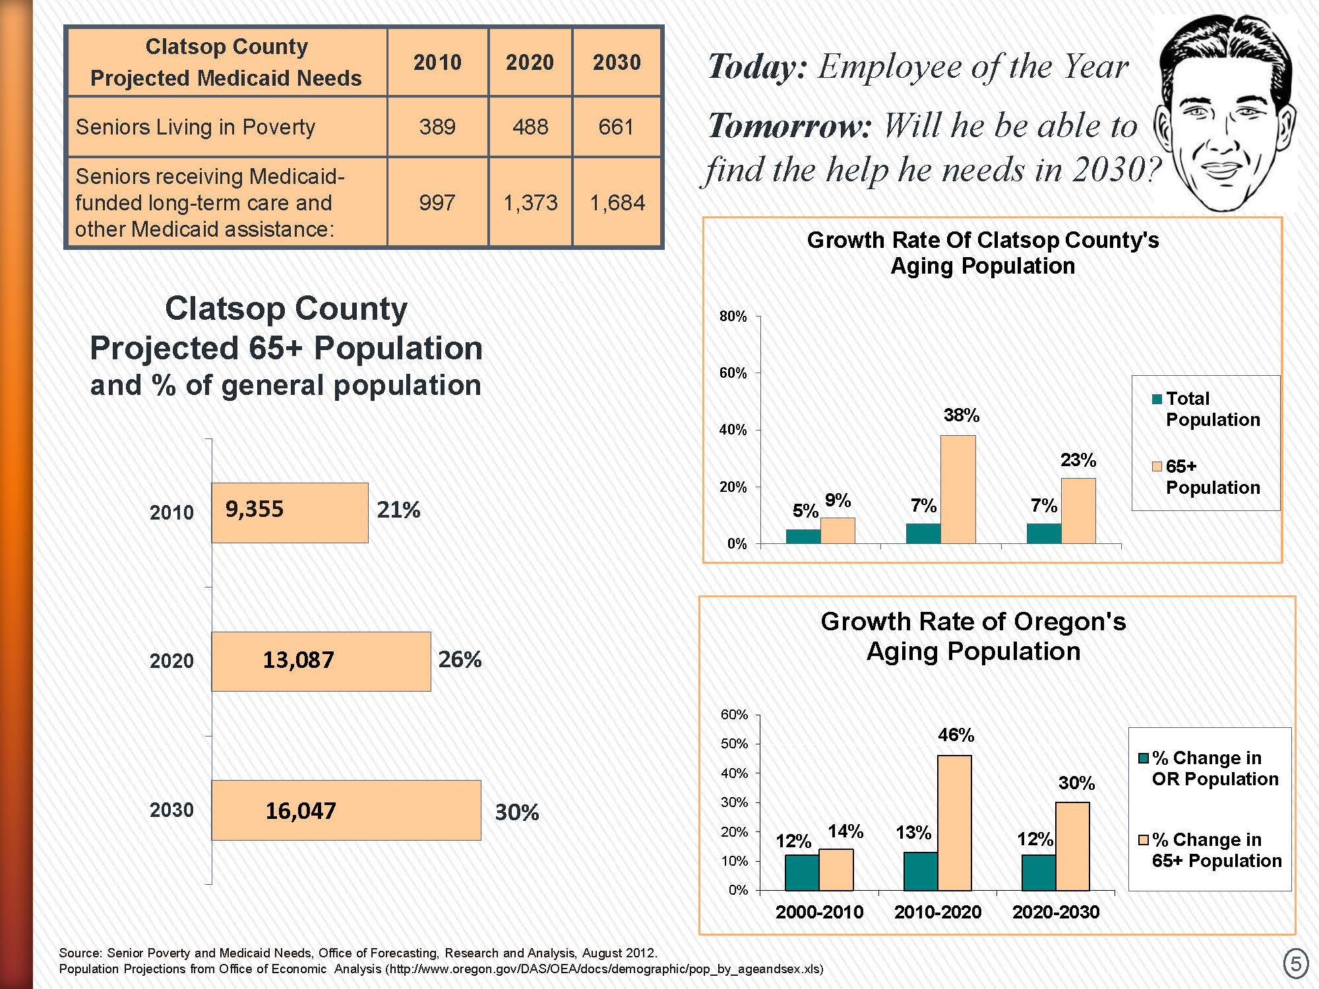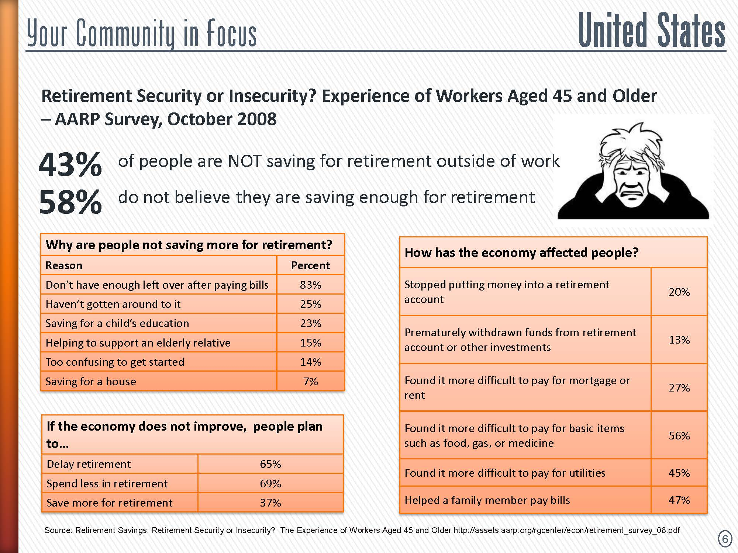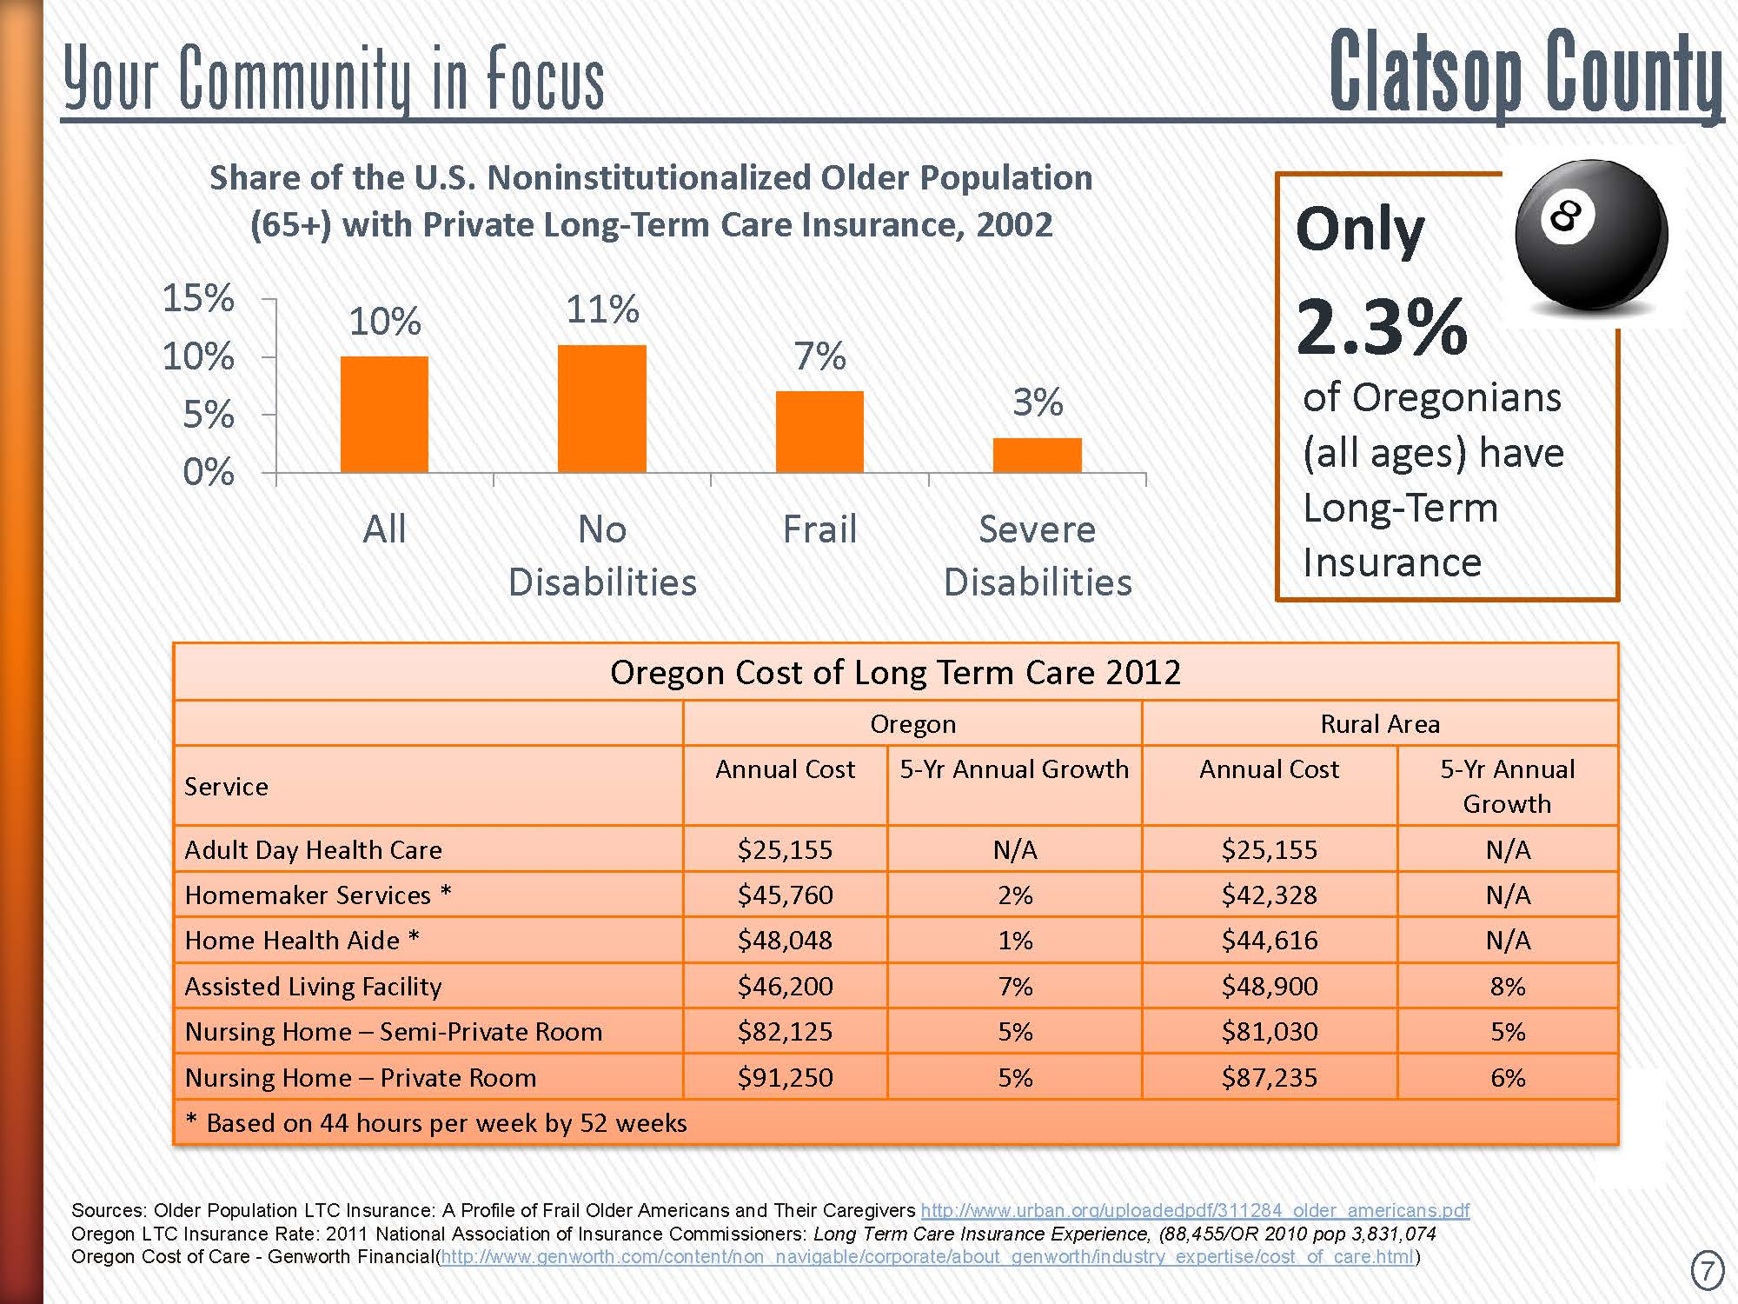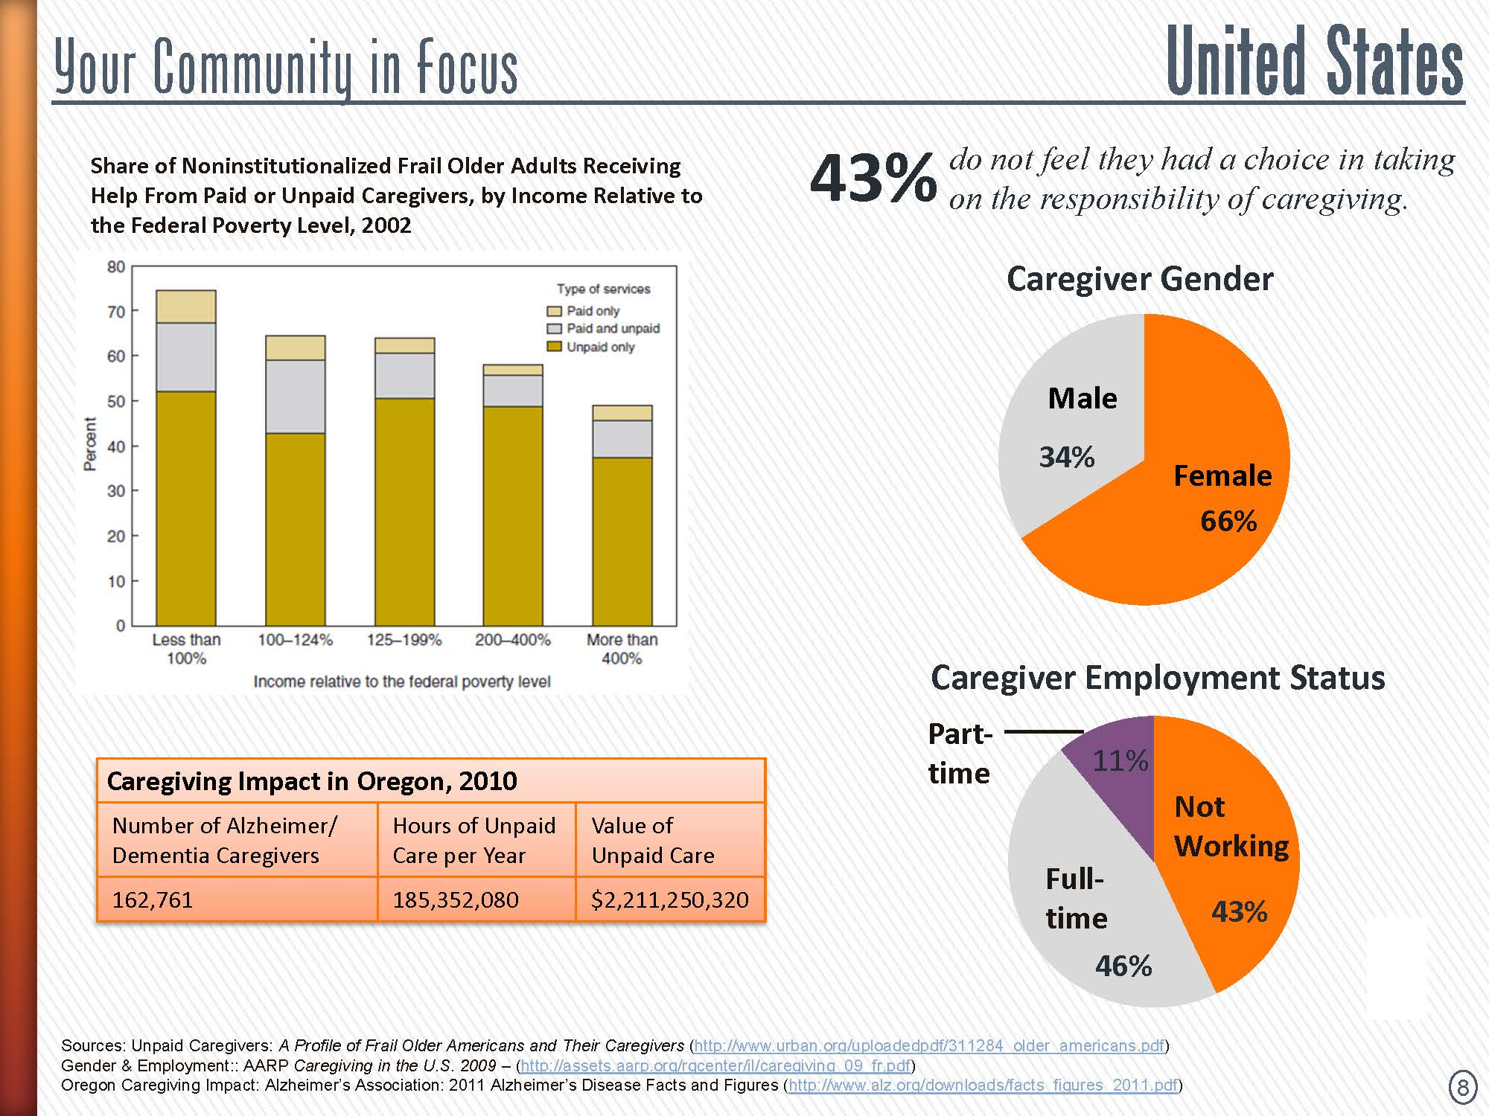
Profile—Clatsop County Transportation District Resources Available to People with Low Incomes, Seniors and People with Disabilities
Sunset Empire Transportation (SETD) is a public transit provider serving all of Clatsop County operating a fixed route service, a Paratransit service, a Dial-a-Ride service and a three-county Medicaid brokerage.
The fixed route system include seven all year fixed routes (4 weekday and 3 weekend routes), 2 summer routes (1 weekend and 1 weekday) and a seasonal route.
The all year weekday routes include Route 10 (Astoria and part-time service to Warrenton and Hammond), Route 20 (Seaside and Cannon Beach with part-time service to Manzanita), Columbia Weekday (Warrenton to Clatskanie), and Route 101 (Astoria to Seaside with part-time service to Cannon Beach). The all year weekend routes include Route 21 Weekend (Cannon Beach to Seaside), Columbia Weekend (Warrenton to Kelso/Longview) and Pacific (Astoria to Manzanita). The summer routes include SETD Streetcar (weekend service in Seaside) and Route 21 Weekday (Cannon Beach). SETD also coordinates services with the Oregon Motor Coachways (NorthWest Point) service to Portland. Ridership has consistently increased over the last four year with monthly averages of: FY 12 – 11,821; FY 13 – 14,309; FY 14 – 14,309 and current FY 15 – 16,585. The fixed route system provided 33,761 rides to seniors and people with disabilities and, on average, about 18% of our ridership are seniors and people with disabilities.
All of Sunset Empire Transportation District’s buses are equipped to carry at least 2 wheelchairs. One bus can carry 4 wheelchairs and one bus can hold up to 3 wheelchairs.
RideAssist provides two demand-response programs – Paratransit and Dial-a-Ride (DAR).
Paratransit service is offered to persons with disabilities or with conditional or temporary disabilities that cannot access or utilize fixed route bus services within the designated route service areas. Paratransit service is curb to curb and vehicles are wheelchair accessible and comparable to the existing SETD bus services being operated within the designated service area.
DAR service is provided in a limited service area to all residents, with priority seating given to seniors and those with disabilities. Vans or small buses provide connecting service to the fixed route bus service and local rides to appointments, shopping, etc.
Reservations for RideAssist service can be made from 1 day to up to 2 weeks in advance. All those making reservations are given a confirmation/ride reminder call the day before. RideAssist ridership has increased over the last four years with monthly averages of: FY 12 – 512; FY 13 – 513; FY 14 – 524 and current FY 15 – 580. RideAssist provided 6,103 rides to seniors and people with disabilities and, on average, about 89% of RideAssist’s ridership are seniors and people with disabilities.
Title XIX Non Medical Transportation requests are managed through RideCare, a regional center serving Clatsop, Columbia and Clatsop counties. SETD also accepts ride requests from the Oregon Medical Assistance Program. Some of RideCare’s requested rides are provided by SETD’s RideAssist. RideCare brokered ridership has increased in the last four years with the monthly averages of: FY 12 – 3,232; FY 13 – 4,000; FY 14 – 4,713 and current FY 15 – 4,870.
The vast majority of transportation for seniors, low income and those with disabilities is provided by Sunset Empire Transportation District. There also a number of service agencies, churches and assisted living facilities that provide transportation on a limited basis to their clients and/or parishioners. What is missing is a coordinated network to maximize the use of these transportation resources.
Community Action Team (CAT) provides bus tickets to clients, depending on availability of grant funding to purchase the tickets. Management Training Corporation (MTC) can pay for bus or gas vouchers for those enrolled in its training programs, while they are participating in the program.
MEDIX is a private ambulance service available to anyone who needs their specialized transportation that can pay for the service. The Medix fleet in Clatsop County includes 6 vans, all of which are wheelchair and lift equipped. The vast majority (90%) of their trips are non-emergency medical visits, with their primary passengers being seniors, those with disabilities and Medicaid recipients. MEDIX averages 400 one-way trips a month, and will travel to Tillamook County, Pacific County in Washington State, Portland, and occasionally Columbia County.
Coast Rehabilitation is the largest residential and vocational program serving individuals with disabilities with its own fleet of vehicles: 1 full-sized or 1 mini-van for each of the residential homes. The scope of services involves vocational program transportation, medical transportation, social and recreational transportation and transportation services for banking, shopping, and access to various community services. The primary geographic area served by Coast Rehabilitation is Seaside north to Astoria. To cover other areas of the county, the Center collaborates with the SETD.
Taxis can be a low-cost transportation option for travel within the cities. However, taxi companies are independent contractors and prefer not to be involved with the public transit system due to the restrictive insurance requirements, level of required paperwork, and lag time to receive reimbursements. Dial-a-Ride is still less expensive than taking a taxi.
Most of the public agencies with special needs clients rely on public transit and do not have any of their own transportation services: Department of Human Services—Self Sufficiency and Northwest Senior and Disability Services, Clatsop County Health Department, and Management Training Corporation (MTC). Clatsop County contracts with Columbia Community Mental Health to coordinate services for people with disabilities who receive state assistance.
Typically, emergency medical transportation is provided by MEDIX through a contract with Clatsop County.
Assisted living facilities in Astoria, Gearhart and Seaside have vans/buses for transporting their residents. However, these facilities primarily transport their residents on regularly scheduled weekly trips—shopping, prescription pick-ups, church and social outings. Typically, assisted living transportation is not used for Medicaid rides, even though the trips are reimbursable, because the facilities have found it is not cost effective to use the vans/buses for single rides. Salvation Army relies on their van for crisis management situations—getting out to clients in times of emergencies—a mobile office for offering on-site counseling. Typically, for clients needing transportation, they work with SETD or find support from other agencies such as the Community Action Team (CAT), churches and St Vincent de Paul, to buy bus passes or vouchers. In a pinch, Salvation Army workers will provide transportation.
Veteran’s Services in Clatsop County has a van. They provide transport to veterans for medical appointments in Portland.
Community Action Team runs the Food Bank for Clatsop County.
Pacific Transit provides 4 routes a day into Clatsop County from Pacific County, Washington.
Finally, the largest transportation provider in the County is the school system. While there is certainly unused capacity during the day, most of the school buses in Clatsop County are not necessarily a good fit for populations with special transportation needs because most of their buses don’t have wheelchair lifts and the widths of the aisles are narrower than a standard public transportation bus.

PROVIDER MATRIX GUIDE

TRANSPORTATION | TYPE | SERVICE AREA | CONTACT INFO | WEBSITE
Adam Airport Transportation | Shuttle | Various Cities (OR & WA) | (503) 754-2649 | www.adamairportshuttle.com
Amtrak | Train/Light rail | Nationwide | (800) 872-7245 | www.amtrak.com
Arrow Taxi | Taxi Service | Astoria/Warrenton/Seaside | (503) 738-4005 | (None)
Astoria Riverfront Trolley | Trolley | Astoria | (503) 325-6311 | www.old300.org
Astoria Senior Center | Shuttle | Clatsop County | (503) 325-3231 | www.astoriaseniorcenter.vpweb.com
Astoria Warrenton Chamber of Commerce | Park and Ride | Astoria | (503) 325-6311 | www.oldoregon.com
Barlow Bikes & Boards | Rentals | St. Helens | (503) 397-4900 | www.barlowbikes.com
Bikes & Beyond | Rentals | Astoria | (503) 325-2961 | www.bikesanbeyond.com
Buena Vista and Wheatland Ferry | Ferry | Buena Vista/Wheatland | (503) 588-7979 | http://www.co.marion.or.us/PW/ferries/buenaferryfees.htm
Checker Cab Central Oregon | Taxi Service | Westport | (541) 312-2227 | http://www.taxi-cab-oregon.com/taxi/services
Chinook Winds Fun Bus | Bus | Lincoln County | (877) 493-7386 | www.chinookwindscasino.com
Clatsop Care Center/Retirement Village | Bus | Private transportation for residents | (503) 325-0313 | www.clatsopcare.org
Coast Shuttle | Taxi Service | Astoria/Warrenton/Seaside | (503) 791-7913 | (None)
DAV Vans | Van | Clatsop County and Portland Area | Phil Simmons | http://davwi.org/vans/
Dwayne's Shuttle | Taxi Service | Astoria/Warrenton/Seaside | (503) 440-7777 | (None)
E & E Auto Center | Rentals | Tillamook County | (503) 842-7802 | www.eandeautobody.com/Rentals.html
Enterprise Rent-a-Car | Rentals | Clatsop County | (503) 325-6500 | www.enterprise.com
Family Fun Cycles | Rentals | Cannon Beach | (503) 436-2247 | (None)
Greyhound | Motorcoach | Nationwide | (800) 231-2222 | www.greyhound.com
Hertz Rent-a-Car | Rentals | Clatsop County | (800) 654-3131 | www.hertz.com
Lum's Toyota Rental | Rentals | Clatsop County | (503) 861-1144 | http://www.lumstoyota.com/warrenton-toyota-rental
Manzanita Bikes & Boards | Rentals | Tillamook County | (503) 368-3337 | www.manzanitabikesandboards.com
Medix Medivan Service | Medical | Clatsop County and Portland Area | (503) 861-1990 | www.medix.org
Mike’s Bike Shop | Rentals | Cannon Beach | (800) 492-1266 (503) 436-1266 | www.mikebike.com
Mom's Cab | Taxi Service | Astoria/Warrenton/Seaside | (503) 325-8210
Northwest Point | Motorcoach | Clatsop County and Portland Area | (541) 484-4100 | www.oregon-point.com
Old Gray Cab | Taxi Service | Astoria/Warrenton/Seaside | (503) 338-6030
Partners for Seniors | Volunteer | Seaside Area | (503) 717-2496
Radio Cab | Taxi Service | Cannon Beach | (503) 227-1212
Red Cross: Oregon Trail Chapter | Volunteer | Clatsop County | (503) 528-5650 | www.oregonredcross.org
Regal Coach Taxi | Taxi Service | Astoria/Warrenton/Seaside | (503) 325-8715
Royal Cab | Taxi Service | Astoria/Warrenton/Seaside | (503) 325-5818
Royal Cab | Taxi Service | Long Beach Peninsula | (360) 665-3500
Seaside Cab Company | Taxi Service | Astoria/Warrenton/Seaside | (503) 738-5252
Sundial Charter Service | Charter | Astoria/Warrenton/Seaside | (503) 325-4484 | www.sundial-travel.com
Wahkiakum Ferry | Ferry | Westport/Cathlamet | (360) 795-3301 | http://www.co.wahkiakum.wa.us/depts/pw/index.htm
Yellow Cab | Taxi Service | Cannon Beach | (503) 505-7945

Assessment of Transportation Needs for People with Low Incomes, Seniors and People with Disabilities

To assess the transportation needs of people with low incomes, seniors and people with disabilities, outreach was conducted to both the targeted populations and to the agencies/entities that serve these residents.

Summary—Surveys with People with Low Incomes, Seniors and People with Disabilities
During June and July 2007, 700 surveys were distributed to low income, seniors and people with disabilities within Clatsop County. 92 of the surveys were returned, a response rate of 13%. Residents from all communities within Clatsop County completed surveys, ensuring geographic distribution corresponding to population density.
Findings
- The majority of seniors, low income and people with disabilities responding to the survey live in Astoria (40%), Seaside (24%) or Warrenton (16%). Of the approximately 6,800 Clatsop County residents with potentially special needs for transportation, it is estimated that only about 30% actually use public transit.
- Nearly two-thirds (63%) of the seniors, low income and people with disabilities responding to the survey either still drive or have access to transportation through family or friends. Over one-third (37%) of those surveyed indicate that they regularly take the bus or Dial-a-Ride to get to places they need to go with the Dial-a-Ride used more often than fixed route bus service. Vouchers and volunteer drivers represent less than 5% of the transportation options used by these residents.
- Reasons for not using public transit (other than because of having access to other transportation) are typically service-related: Bus doesn’t come close enough to where I live/inconvenient stops (27%), Can’t use bus because of disability/can’t walk that far (16%), Time consuming/too many transfers/buses don’t run frequently enough (12%), Too expensive (9%), Bus doesn’t go where I need to go (4%), and Unfamiliar with bus system/unaware of stops/routes (3%).
- Of the seniors, low income and people with disabilities taking public transit, two-thirds (65%) rate their overall experience excellent or good. On most characteristics, these riders rate their public transit experience excellent or good: Timeliness, courtesy, helpfulness, and knowledge. 53% rate the NW Ride Center excellent or good, although nearly one-third (30%) of those responding to the survey aren’t familiar with the service.
- Over half (53%) of the special needs populations interviewed have missed going someplace due to a lack of transportation, indicating an unmet need among these residents. Reasons given (multiple responses) include: No car (58%), friends/relatives couldn’t take me (47%), bus doesn’t go where I need to go (31%), no license (29%), bus doesn’t run at the times I need (27%), bus doesn’t come near where I live (27%),bus costs too much (22%), and can’t use bus because of disability (11%).
- Primary trips are for medical visits, shopping, and (jobs) classes/work search/training.
- Recommendations for improved Sunset Empire Transportation District service from these populations include: Lower prices (19%), More stops/routes in town/neighborhood (17%), Expand hours of service/evenings/early mornings (11%), More stops/routes in outlying areas such as Warrenton and Svenson (11%), Run buses on Sunday’s (11%), and More direct/non-stop routes/between cities such as Astoria, Seaside and Cannon Beach (10%).
Note: A new Rider Survey is planned to be conducted in the 2011-12 fiscal year.

A bus stop analysis was performed over a two week period in October 2010, to see which bus stops are used more frequently by the senior and disabled populations.
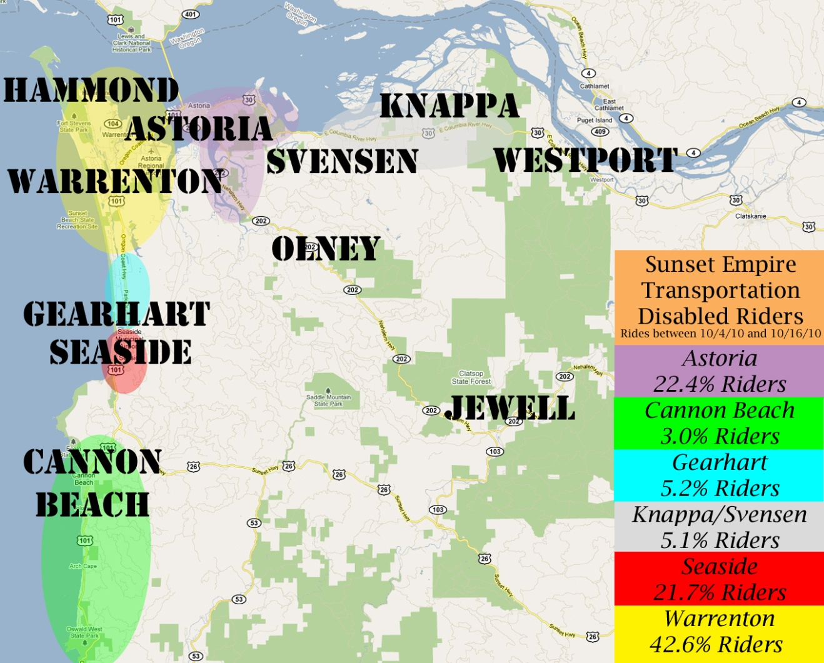

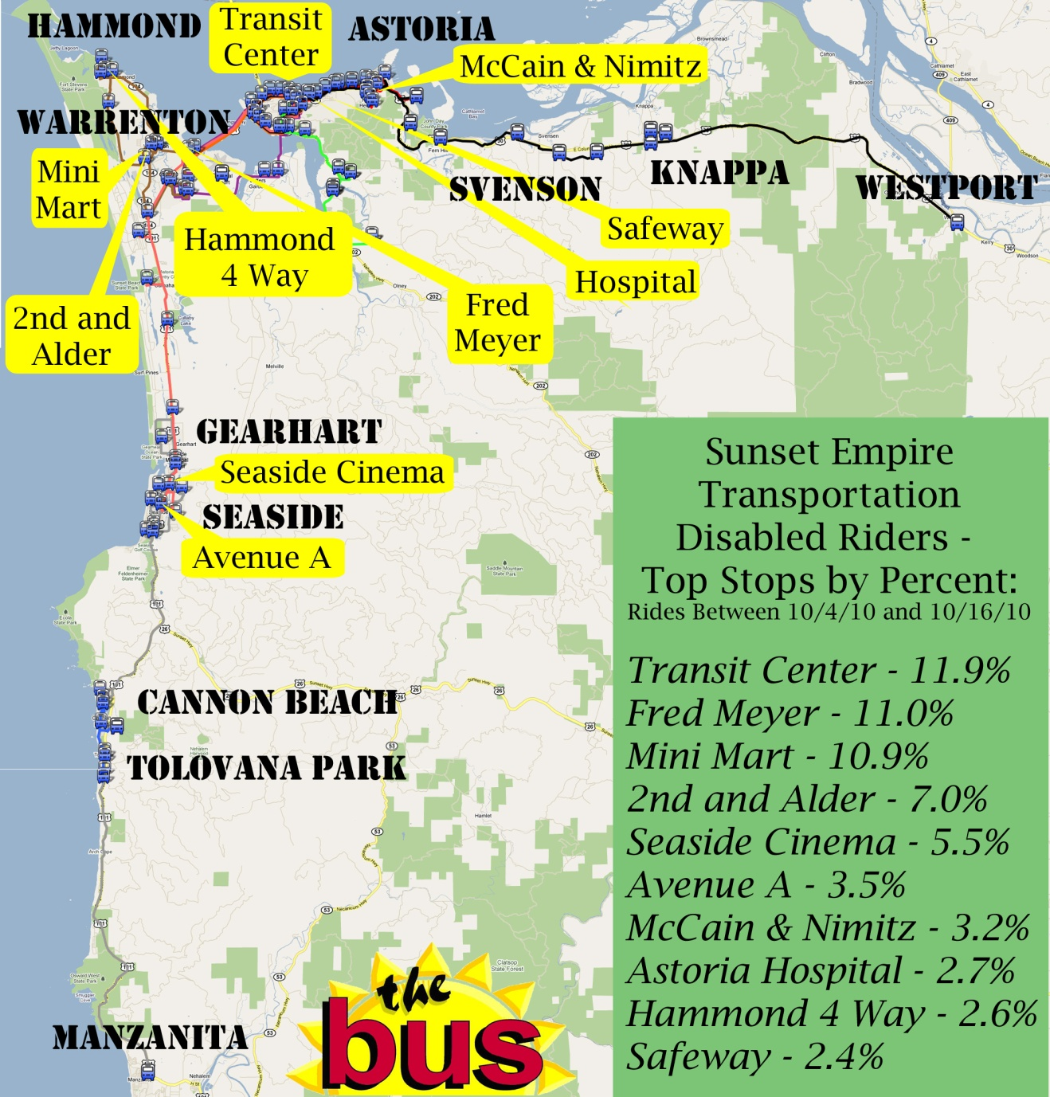

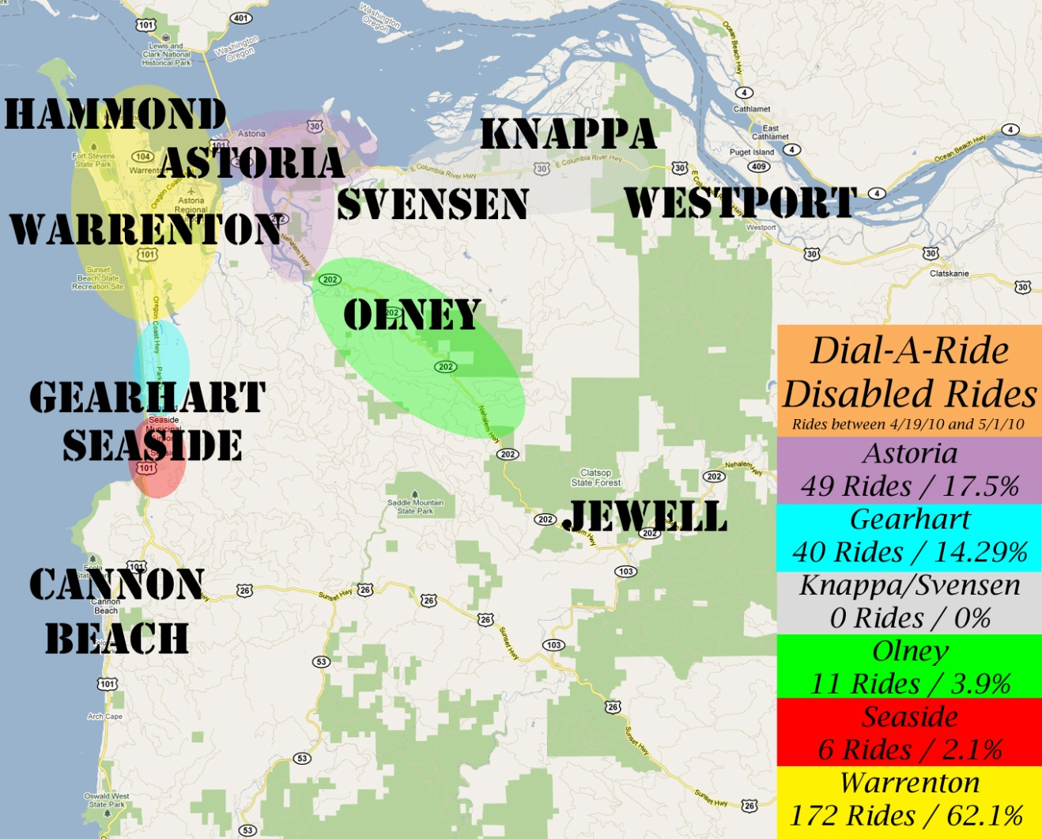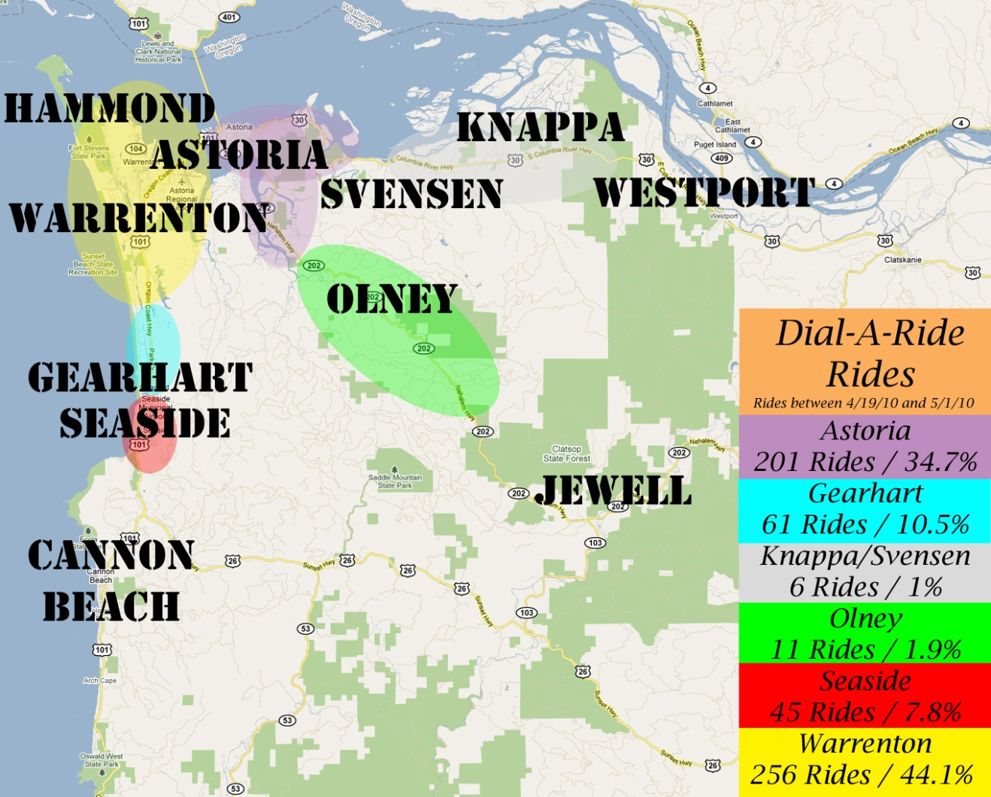
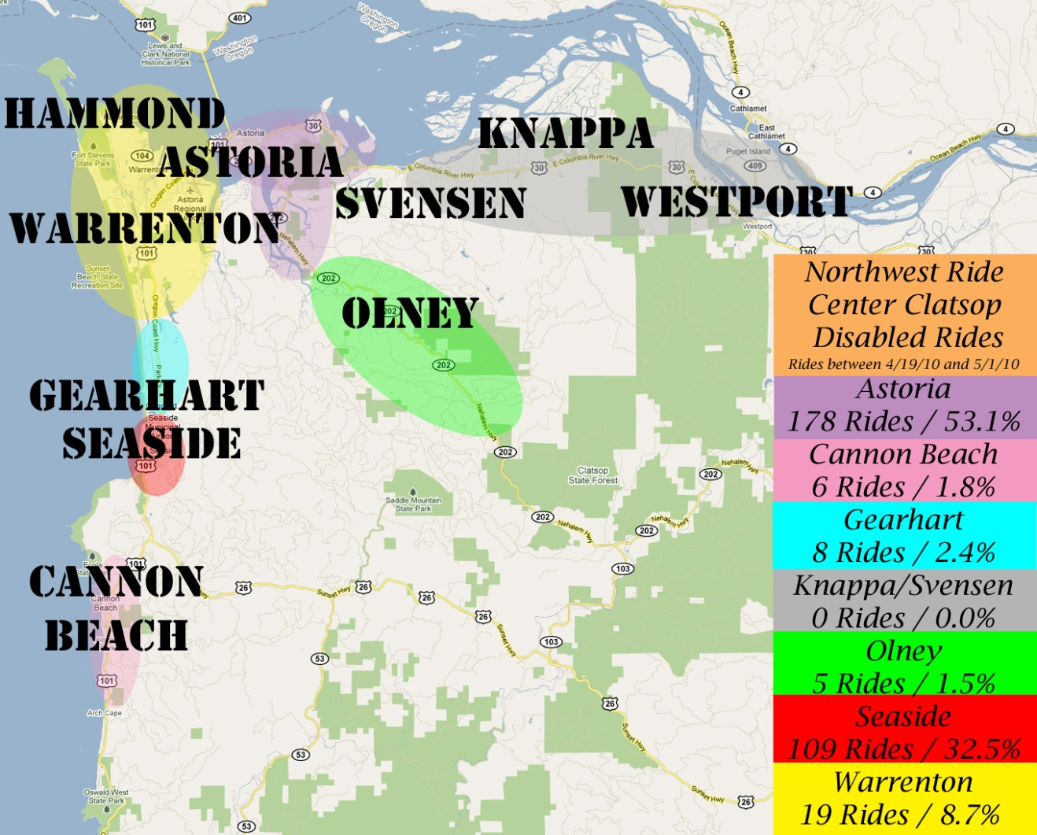
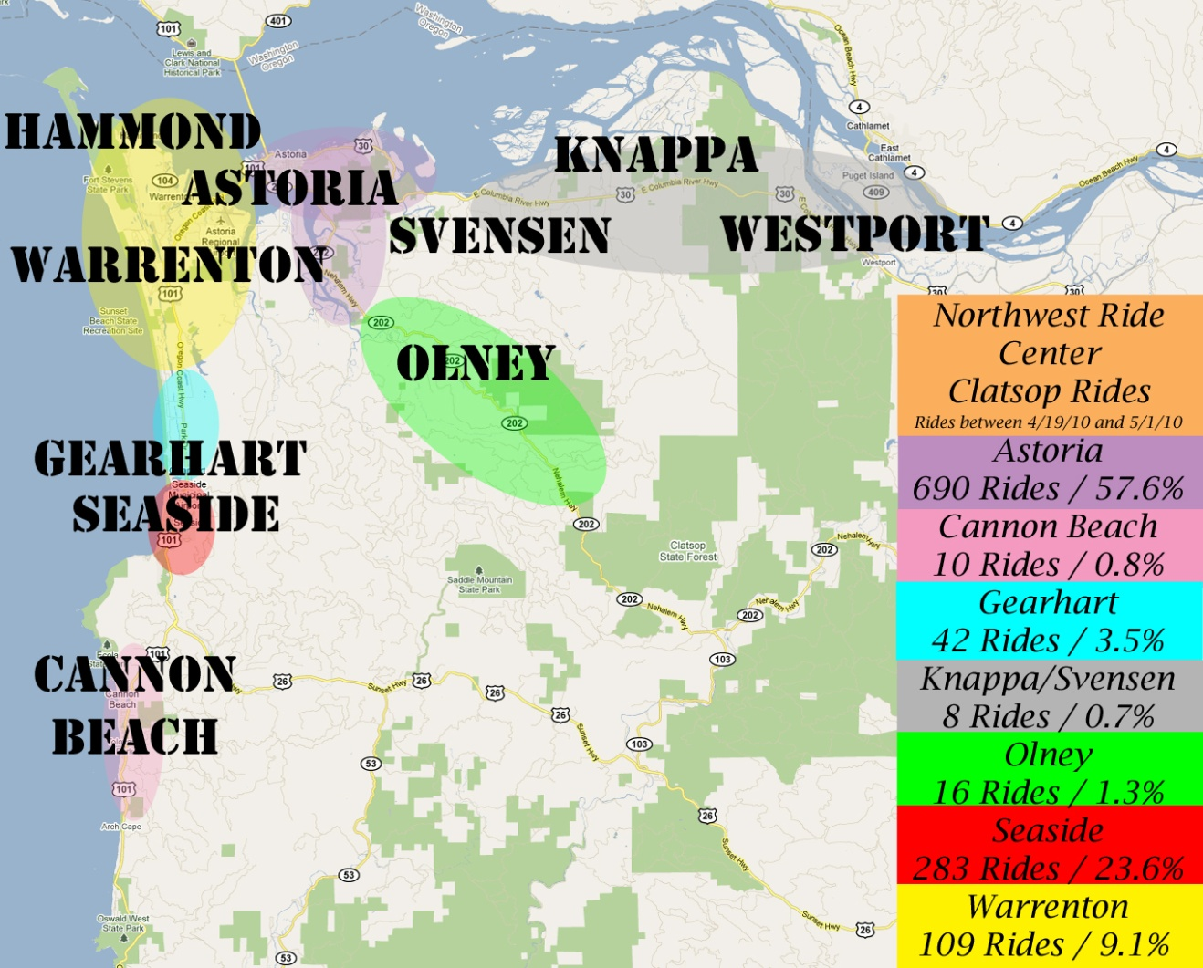

Summary – Interviews with Agencies/Entities Serving Seniors, the Low Income and People with Disabilities
Personal interviews were conducted with the Department of Human Services, Community Action Team, Veteran’s Services of Clatsop County, Northwest Senior and Disability Services, Clatsop County Health Department, Management Training Corporation, Community Action Team, Metro West, Coastal Family Health Center, Clatsop Community College, Coast Rehabilitation Services, DHS—Office of Rehabilitation Services, Clatsop Developmental Disability Program, Integrated Services Network and NAMI. While the majority of special needs populations have access to transportation, agencies serving these populations still see a segment of their clientele having unmet transportation needs.
Findings
- Generally, those serving the low income, seniors and people with disabilities find public transportation ranges from “adequate for a rural county” to “pretty good given the limited funding and spread out need for service.” Community agency partners are “grateful to have what we have. Sunset Empire Transportation listens to the needs of the community, and has committed and helpful staff and bus drivers.”
- The system works best for those living in the more heavily populated communities along or near Hwy 101 (Astoria, Warrenton, Seaside) and for the most mobile of the special needs populations. For the less mobile and those living outside the population centers, accessing public transportation can be a challenge.
- Community Action Team (CAT) estimates 80% of their 800 monthly walk-in clients rely on public transportation. Primarily low income families, many of these clients live in the more rural parts of the county because of housing affordability. Their transportation needs include getting to work and/or classes at Clatsop Community College—often in the evenings when buses don’t run. Individuals with lower incomes and less education often have fewer transportation options. Mothers with children who must rely on public transportation also deal with transporting strollers, groceries, etc. The difficulties of managing kids and groceries on public transit are compounded by having few bus shelters to stay out of coastal inclement weather. Along the Hwy 101 corridor, there are no lighted bus stops, which is a safety issue for both passengers and drivers.
- Management Training Corporation (MTC) has similar issues with their clients—difficulty accessing public transit in outlying areas (Jewell, Knappa, Svenson), having to coordinate training/work schedules to bus schedules, and frequency of service. Also when bus schedules change, it is important to inform local agencies working with special needs populations. SETD now has a schedule-change checklist it follows which includes informing stakeholders, agencies, the press as well as riders of upcoming changes. There is also a bus schedule distribution route that serves over 110 agencies twice a month.
- The Women’s Resource Center has a number of clients that can’t afford the bus and suggest a reduced rate monthly pass would be helpful. They also serve a number of clients in the Knappa area which doesn’t have fixed route service. Additionally, “Many of our clients are fearful of riding the bus because they aren’t sure of where they are going. Riders clearly identified as ‘Bus Buddies’ would be helpful. Finally, the Center also underscores the need for one bus/limited stop service between Astoria and Seaside. Most of these issues have been resolved, by offering the Hwy 101 Express, hourly between Seaside and Astoria and launching the new RIDEPAL travel training program.
- While complementary para-transit/equal service to the disabled is required, it is becoming more difficult to provide as an adjunct to the fixed routes. Some bariatric riders require multiple lifts to accommodate both themselves and their wheelchairs—time consuming on a tight schedule. The small 3 wheelers being used by some individuals with disabilities aren’t designed for transporting on public transit as the seats don’t tie down—resulting in unstable transport around curves and stopping. SETD purchased a specially designed bus, equipped with extra wheelchair spaces and a special lift, for bariatric transport. Driver Supervisors attended a Advanced Securement Class put on by the National Transit Institute to learn techniques in securing oversized and uncommon mobility devices.
- A biggest issue raised by medical providers is cost and frequency/speed of service for their patients. “When there is a problem, it is usually because someone misses the bus or it takes too long for the bus to get here. Round trip from Seaside to Astoria can take hours, and if you happen to miss the bus, it is a while before there is another one.” Family Coastal Health Center will purchase bus tickets for those unable to get in for their appointment, but also note that juggling schedules when someone is late for an appointment is hard on staff. Most of these issues have been resolved, by offering the Hwy 101 Express, hourly between Seaside and Astoria.
- For those working with senior and people with disabilities, it is important that attitudes change regarding the transportation. “Seniors and the disabled needs for transportation are different from people who are mobile.” Being dropped off on the highway instead of at the door is a problem for the frail and weak. Waiting on the highway is also a safety issue. “Need to get into the mindset and lifestyle of our (special needs) clientele, and how they use and rely on the bus.” Drivers and staff are receiving additional training through the Mobility Coordination program. This has provided them with the opportunity to experience what it’s like for the client to travel using transit and Dial-A-Ride services.
- Door-to-door service for special needs populations residing more than ¾ mile off the fixed route is only available for medical trips. Women using Women’s Resource Center services often do not have any personal means of transportation and need daily transit to sheltered worksites. Dial-a-Ride is not available to them because they need services every day.
- A broader issue raised by community agency representatives is the concentration of services for special needs populations in the larger metropolitan area. For example, most veterans’ services are in Portland. The expectation is that clients need to go to the services (rather than the services provided locally), and that it is most cost effective to provide services in the more populated cities. SETD is working towards increasing transportation options and awareness of options for clients whether traveling within or out of the county. Some examples are the Mobility Travel Training program and offering free DAR service for veterans traveling to local medical appointments.
- Sunset Empire Transportation District staff is described as very supportive and accommodating when working with special needs populations. Organizations appreciate being billed for bus passes rather than having to coordinate payment for clients at the time of purchase. The Northwest Ride Center is described as becoming more responsive to people’s needs; for example, improved flexibility on same day service for appointments.

Sunset Empire Transit District Coordinated Transit Plan
2009 Updates

Strategies/Activities Addressing the Identified Gaps and Efficiencies in Service Delivery

Coordination To Maximize Public Transportation Resources:
Agency | Action | 2009 Progress
Northwest Ride Center | Columba, Clatsop, Tillamook share a central brokerage staffed in Astoria, for Medicaid Demand Response. | Continues to keep cost down by covering a tri-county area. Growth is up 8.5% from October 2008 to October 2009.
Senior Centers, Human Service Agencies & Medical Services | SETD fixed route stops at facilities serving special needs populations such as Department of Human Services, CARE, MTC, Oregon Employment Department, and Seaside Memorial Hospital | Increased ridership, and awareness of SETD’s desire and effort to improve service.
Oregon Coachways | Two round trips daily are made to the Portland Transit Mall via Hwy 26. | Ridership to Portland utilizing this service increased substantially in 2008. A second round trip was added in March, 2010.

Needs | 2008 Progress | 2009 Progress
System Accessibility | Extended routes/frequency from what was offered in 2007 including a 3-day per week Westport connection to Columbia County Rider. | Extended service area and frequency again, from what was offered in 2008, including service to the area of Costco, hourly service to Knappa/Svenson and 3-days per week service to Hwy 202.
System Capacity | Ridership increased 25%. Need bigger buses on Routes 10 & 12 in Astoria and 101 Express (Astoria-Seaside) as these are reaching capacity during peak hours. Contracted with Clatsop Community College | Ridership increased 83%. Expanded service to offer 30 minute service during peak hours on Routes 1o, 12 & 15. 5 new buses were purchased with a grant, which will help alleviate congestion & replace buses that have reached their useful life.
Demand Response Accessibility | Dial-A-Ride service to dialysis clients is reaching capacity during the regular hours of 8:00 a.m. and 5:00 p.m. A grant was received to expand service hours to 6:00 a.m. to 6:00 p.m. and Saturdays from 8:00 a.m. to 5;00 p.m.  Fixed route service to Camp Rilea Satelite VA clinic provided upon client request. | Grant received to purchase handicap accessible Veterans Van for local VA office. Veteran’s services paid the 10.27% match.
Demand Response Capacity | Dial-A-Ride provides 10,000 trips per year during the 8:00 to 5:00 shift, and 500 trips after hours.
Affordability of Non-Medicaid Demand Response | Private pay transit is expensive. People continue to slip through the cracks, don’t qualify for Medicaid, but still have low incomes. | Veterans receive too much military retirement to qualify for Medicaid, yet can’t afford the private pay transit alternative. Senior and disabled Veterans attending local medical appointments can receive free DAR transportation.  Medicaid people who are not OHP Plus are falling through the cracks, dialysis especially are being impacted because they have to pay their own fare while still being on a fixed income.
Senior Center System Capacity | Sunset Empire provides van, does maintenance, and allows them to use the SETD card lock for fuel (so don’t have to pay gas taxes) for $1 year, with the Center using their own volunteer drivers. In 2008, SETD ordered the Center a new bus, enhancing their transit capacity. The senior center is paying the 20% match for this 5310 grant. | August 2009-Astoria Senior Center receives new bus.
Public Input to SETD on the Transportation Needs of the County’s Special Needs Populations | In 2008, SETD revised the bylaws and increased the duties of a sub-committee to the Sunset Empire Transportation Board to update the Coordinated Plan and pursue networking opportunities identified through the MIG process: Senior and Disabled Transportation Advisory Committee. | July 2010- SETD continues to hold Senior & Disabled Advisory Committee meetings.  Another committee is also being organized, regarding the fixed route system. Members will be users and supporters of the system.  SETD has formed a consortium (GRO Transit) for the purpose of securing grant funds for regional transit projects. Five grant applications have been submitted to date ranging from increasing transit access to improving passenger amenities.
Travel Trainer/Mobility Manager—Transit Training Program | Has already been developed, next step is implementation. | May 2010-RIDEPAL (Passenger Assistance Link) travel training program officially launched.

Service Enhancement | 2008 Progress | 2009-2011 Plans
Identify better/safer stops for fixed routes | Moving or revising the current Fred Meyer stop-currently being discussed and new locations being considered. | New plans are being explored for revision of the current Fred Meyer location.
Combine SETD maintenance service | With school buses and private coach carriers through a shared Bus Storage and Maintenance Facility. | Discussions continue to explore future options as growth continues.
Prioritize concentrations of employment population | Explore van pools for centers of employment, eg, Knappa/Svensen/Westport to Wauna Mill van. | Funding was previously turned down. Will continue to seek funding to support this need.
Further analyze the aging of the population in Clatsop County | Future impacts on transportation—Need may be greater than the statistics indicate, particularly for medical and other essential trips into Portland.  Lack of medical specialists in the County means residents must travel outside of the area for these services. Also, as the population ages, the less mobile people become, placing additional demands on public transit. | Continued improvements to the current transit routes and path of travel. Both will be more user friendly and accessible with improvements such as additional bus stop signs featuring schedules, maps/schedules placed in shelters, additional shelters, flashing LED handheld lights, fold-out pocket schedules, enhanced website and travel training program.
Partner with more agencies | Partnered with Columbia County Transit to improve connectivity at the east side of the county in Westport. | Began partnering with local Veterans Services in 2009. Will continue to help them improve transportation options for veterans.

Relative Priorities of Strategies

The STF Agency periodically assesses local transportation needs of the disabled, elderly and low income, and their transportation providers in order to stay current with present needs, and to identify emerging needs. The STF Agency supports efforts of local providers in meeting the transportation needs of the disabled, elderly and low income. Such support includes technical assistance and identification of resources that enable providers of transportation services for the disabled, elderly and low income to:
- Increase safety and comfort for riders with disabilities and mobility devices
b. Preserve existing transportation capabilities (preventative maintenance, rehabilitation of transportation resources, vehicle
Replacements, etc)
c. Meet operational costs of existing transportation services and expanded services as needed. Add new services as resources
Become available and the ridership population increases;
d. Maximize their capability to meet transportation needs to employment and education centers, as well as human service agencies of the disabled, elderly and low income through creative and innovative measures; and,
e. Augment their existing capabilities through the purchase of transportation services from the SETD (contract services, purchase of tokens, vouchers, etc)

To that end, FY 11/13 STF/5310, New Freedom and Job Access Reverse Commute (JARC), Intercity Grant priorities for the targeted populations are:

FY 11/13 STF/5310 Grants | Priorities for Special Needs Populations/Gaps in Service Being Met | Performance Measurement
Travel Training for senior/disabled, low income and those with limited English proficiency  Targeted outreach for specific populations | Travel training is one of the most effective ways to encourage/increase the use of public transit by special needs populations. This request would implement the training program already developed. This program also helps develop an outreach program for community members with limited English proficiency, as well as increased sensitivity awareness for special needs populations including the utilization of alternative formats. Continue to expand outreach to limited english populations. | Increase use of fixed routes by 5%15% and decrease rides on Paratransit by 5%  To implement a county wide Demand response system “Dial A Ride”  by riders previously using Demand Response service.
b. AVL technology –purchase companion software  (to the previously purchased DAR software)  for fixed routes. | Will improve operations by significantly by improving the effectiveness of data collection, on time performance and route planning by using real-time information available through the technology program for fixed routes. | Increased on time performance of fixed routes by 5%
c. Ticket Bank & veterans/school program. | Expand transportation support services by expanding current ticket bank program, and enhancing veterans and school program modal options. | Increased use of ticket bank program by 5%
d. Purchase new maintenance vehicle/Shop truck | Current maintenance vehicle is at the end of its’ useful life. | Reliability and savings on repairs of maintenance vehicle.
e. Camera purchase for buses; upgrade dated  camera systems and install cameras in  Remaining vehicles that do not yet have them. | Increases safety on and off the buses for passengers and staff. Cameras are equipped with a panic button feature that when activated by the driver designates an incident that will need reviewing. Forward-facing views show the road and other traffic. | Increased safety on the transit system, and supplies recorded evidence in the event of an incident, resulting in increased ridership and fewer potential disputes arising due to no evidence (if cameras were not being used).

FY 11/13 New Freedom Grants | Priorities for Special Needs Populations/Gaps in Service Being Met | Performance Measurement
- Partner with local veteran services to increase transportation options available. | Increases transportation options available for veterans and simplifies the process of arranging and using the modes. Operate a six-month trial of veterans using the NWRC as the call center for reserving their transportation. | Will simplify process; measured by number of users and feedback from local veterans services staff and clients.
b. Development of Emergency Preparedness Plan  for Transportation of Disabled and Elderly to  Shelters and Medical Facilities during Disasters  and Emergencies & purchase of Emergency  Management software by partnering with CRS. | Purchase software that will provide a volunteer database for disabled and senior clients that need transportation services when disasters and emergencies strike. | Software research is currently being done, with the goal of purchasing by 2012.
c. Solar retrofits for existing shelters, and solar  lights for bus stop signs. | Increased safety and more user friendly for ridership. | Increased use of fixed routes by 5%
d. Phase II DAR software upgrade purchase | This will complete Phase II of the DAR software being purchased, including terminals in each DAR vehicle for dispatch/driver communication. | Completes technology upgrade: will allow smooth information gathering and communication between drivers and dispatcher.
e. Hwy 53/Jewel/Elsie rural demand response  service | Provides on demand transportation to an area currently underserved. | Increase demand response ridership by 5%
f. More frequent bus service to shopping,  employment and human services in Warrenton. | Increases linkages to affordable housing, employment, low skill and access to places of employment for special needs populations | Increase ridership by 5%

FY 11/13 Job Access Reverse Commute (JARC) Grants | Priorities for Special Needs Populations/Gaps in Service Being Met | Performance Measurement
a. Extend bus service hours to meet needs  of low income service sector employees  who work shifts | Service sector employment and job training are often during evening and weekend hours when service is not available | Increase after hours rides to service sector jobs by 5%
b. Clatsop Community College-extend  service hours for access to/from evening  classes. | Economic downturn is redirecting displaced workers back into the community college system for retraining. Currently there are no transit options for those taking evening classes. | Increase ridership to Clatsop Community College by 5%
c. Small business and employer pass  program in accordance with Section 132  of the Internal Revenue Code of 1986 | Benefits the environment, workers and SETD. SETD already has a list of all employers in Clatsop County. Needed is to identify the transportation needs of their employees: service area, hours, and days of the week. | Provide a minimum of 5 presentations to employers. Implement a minimum of 2 new employer-paid programs
d. Employer Guaranteed Ride Home Program | Increase comfort level for workers using transit to and from work. | Increase ridership frequency by employees by 2%.
e. Purchase Bike Lockers

FY 11/13 Intercity Grants | Priorities for Special Needs Populations/Gaps in Service Being Met | Performance Measurement
a. Mobility Management  expand Veterans  transportation options for  travel between cities | Expand Veterans transportation options for travel between cities through education and outreach through the Mobility program. | Increased Veterans ridership by 5%.
b. Marketing | Purchase of Z-cards, print space in visitor guides and similar printed material, and radio outreach to increase awareness and use of Intercity connections | Increased ridership by 5%
c. Vehicle | Purchase second vehicle for use on Intercity route for enhanced reliability and capacity. | Room to accommodate increased ridership and reliability.

FY 11/13 Planning Grants | Priorities for Special Needs Populations/Gaps in Service Being Met | Performance Measurement
a. Systems Design Plan | Establish systems 5-10 year design plan for ridership, routes and service analysis. | Improved system by finding inefficiencies and taking steps to correct and enhance current system.

FY 2011-2013 Priorities and Grant Possibilities
Task | Goals | Funding Sources
1. Maximize use of Technology for Operations | Electronic Ticketing System,  GPS Tracking/ ADA Announcements for buses, shelters, and the transit center, ADA Paratransit mapping software | 5311, Intercity, New Freedom
2. Initiate advertising policy | Integrated marketing for website, schedules, maps and other outreach, alternative ticket sales through creative partnerships (example Seaside Pool, Library, etc.), LEP Plan, Target new partnerships with large employers and student populations, | 5311,
3. Set up Maintenance Plan for Facilities/ Security | Generator for facilities, Increase or develop and implement plan for employees, riders, facilities and equipment | Planning grants
4. Expansion of service  Replacement Buses, Van Pooling, Demand Response Service | Expand service to the interior of the county, create a hybrid route of #12 & #15, hourly service on 101, non medical rides restored, expand ADA Paratransit beyond ¾ mile, Cycle out old buses that are beyond their useful life and purchase new ones that accommodate route and rider needs | 5311, New Freedom, Transit in the Parks/National Park Funding
5. Environmentally Friendly practices encouraged to reduce costs and minimize carbon footprint | Single call center/ one stop shop center for Paratransit, Veterans, Medical in one place, Review fare structure Policy
6. Economic development partnerships with businesses | Local communities include SETD in planning/ build relationships with MOU’s in place, Seaside Transit Center revisited, Park and Ride Pedestrian Access Study | Planning Grants

Opportunities for Future Collaboration
NW Oregon (Clatsop, Columbia and Clatsop counties) is uniquely positioned to coordinate and work cooperatively to serve seniors, individuals with disabilities, and those with limited incomes. Major highway corridors already link (and criss-cross) the three counties, and working partnerships already exist with the NW Oregon Area Commission on Transportation, NW Oregon Economic Alliance and Columbia-Pacific Economic Development District. In addition, the NW Ride Center, Columbia Pacific Coordinated Care Organizations and state agencies such as the Department of Medical Assistance Programs have regionalized to serve the three-county area.

Four immediate opportunities for future partnering and collaboration are currently being explored:
- Improving inter-city connections to Columbia County and Kelso/Portland—extending current service from Westport to Clatskanie will allow SETD and Columbia County to share a stop in Clatskanie. This would mean that Clatsop riders will have access to the Amtrak and bus stations in Kelso on a consistent basis. Look at possibility of going directly into Longview/Kelso to maintain Connector routes as a part of the Connector system. There is also the potential to add the Tongue Point Job Corp students currently taking the Tongue Point bus to Kelso on Fridays.
- Coordinate volunteer programs—Volunteers and volunteer drivers can be an effective way to increase transportation services to special needs populations. Certain economies and efficiencies are added if the coordination, training and dispatch activities are centralized.
- Coordinate transit planning—One central public transportation planner for the three counties will allow greater coordination of transit routes, schedules, and facilities. Further transportation coordination opportunities are being explored with the Veterans Administration and possible vanpooling opportunities. Northwest Connector Program
- Continue with implementation of RIDEPAL: Travel Training and Mobility Coordination program. Include: Extension of the ADA boundary beyond the ¾ mile radius, expanding the 55 alive programs at area senior centers, taking buses out to senior centers, coast rehab homes and showing how the lift works, how to pay a fare/use a bus pass—in a relaxed training environment, and assigning Ride Pal’s to individual new riders. Ambassadors profile out all the trips needed by the new rider, put together the routes that best fit those trip needs, and ride along with them until they are comfortable riding by themselves. Ambassadors ride free when working with a new rider. The program is also expanding the number of printed materials offered in Spanish. Offer Non-Medical rides to seniors, people with disabilities and veterans through a demand response service
- Connector Project and The Northwest Oregon Transit Alliance
- Another immediate opportunity for enhanced collaboration is to develop a Tri-County Coordinated Plan for Clatsop, Columbia and Clatsop counties. Tri County Transportation Options program Northwest Transportation Options is addressing the need for coordination and development of transportation options that explore other methods of transportation such as waking, biking, ridesharing and transit.
Stakeholder Involvement
To date, 4 public meetings have been scheduled to update SETD’s Coordinated Plan:
- December 15, 2010 SETD Public Transit Advisory Committee Meeting
December 16, 2010 SETD Board Meeting
- January 24, 2010 Senior & Disabled Advisory Meeting
- January 25, 2010 SETD Public Transit Advisory Committee Meeting

A public hearing and adoption of the updated Coordinated Plan will be held on:
January 27, 2010

The following organizations and individuals were contacted and/or involved in the development of this Coordinated Plan:
Astoria Senior Center
Clatsop Community College
Clatsop County Developmental Disabilities Program
Coast Rehabilitation Services
Coastal Family Health Center
Community Action Team
Department of Human Services—(NW Senior and Disability Services)
DHS—Office of Voc Rehab Services
Integrated Services Network
Management Training Corporation
Seaside Providence
Clatsop Health District
Medix

Providers of RideCare
NAMI
Oregon Employment

The Harbor
Northwest Regional ESD

Clatsop Community Action
Veterans Services- DAV van transportation

Transit Dependent Populations
Transit dependency is usually defined as being unable to aford reliable personal
transportation, not having a driver’s license or being unable to drive a car. The transit
dependent population is primarily composed of four demographic groups – older adults,
people with disabilities, low­income individuals and families, and adolescents. The
older, poorer or more disabled the citizenry, the more likely transportation assistance is
needed. It should be kept in mind that many seniors continue to drive and in fact make up
almost 15% of al drivers in Oregon. At the same time, more than one in five persons
aged 65 and older do not drive. 1 This percentage of adult non­drivers increases
significantly with age.

MIG Project Plan
(Updated December 6, 2010)

The primary goal of the MIG project is to engage the community planning process to specifically evaluate the current status and future opportunities for transportation supporting access to work for people with disabilities. Because of the severity of weather events impacting the county since 2007, SETD is expanding the MIG Project Plan to include emergency transportation access for disabled, medically dependent and frail populations during natural disasters.

Transportation to Employment for People with Disabilities—Agencies/Companies Currently Providing Transportation Services to Persons with Disabilities
Within Clatsop County there are approximately eight community agencies that work with employed individuals with disabilities: Coast Rehabilitation Services, Clatsop Developmental Disability Program, Integrated Services Network, Clatsop County Health and Human Services, Department of Human Services—Office of Vocational Rehabilitation Services, National Alliance of Mental Illness of Oregon (NAMI), Worksource Oregon—Veterans Employment Office, Management Training Corporation, and Oregon Employment Department:
▪ Coast Rehab Services (CRS), with 9 homes, serves approximately 60 developmentally
disabled residents. Each home is assigned one vehicle, but most are equipped to handle only
one wheelchair at a time. A passenger bus equipped to take 4 wheelchairs would greatly
enhance operational efficiency because getting multiple residents in wheelchairs to work is a
scheduling problem utilizing the one chair capacity vehicles. CRS also serves non-resident
clients in their employment programs and unless they live on a fixed bus route, getting
To/from work can be problematic. Of the approximately 80 individuals with disabilities who
work, about 50% are in wheelchairs. SETD purchased a specially designed bus, equipped
with extra wheelchair spaces and a special lift, for bariatric transport.
▪ For many residents, getting to work is their most important transportation need.
Transportation for some jobs, such as janitorial crews with late night hours, is a problem as
there is no bus service after 8:00 pm. Some of those with disabilities who are currently not
working would be able to work if public transit had more flexible hours. Provision of transit
at non-traditional hours continues to be a high priority for SETD if funding becomes
available.
- The DHS office of Voc Rehab Services provides education/employment training for those with developmental disabilities. With no transportation vehicles of their own, Voc Rehab purchases bus passes/vouchers from Sunset Empire Transit for those with limited incomes.
SETD started a “Ticket Bank” funded at $10,000/year, providing service providers with one flexible centralized distribution center for client transit vouches and passes.
▪ Clatsop Developmental Disability Program doesn’t have any funding for transportation
subsidies for those with disabilities, but works with Coast Rehabilitation Services to transport
those individuals unable to access public transportation either because of the cost or their
physical/geographic/hours of employment limitations. Fixed route buses passes to DHS’s Open
Door Program, which provides mental health group classes, has been introduced. Twenty-three
clients now have access to jobs and college. Service providers no longer need to pre-purchase
vouchers. SETD is also considering revising the current Fred Meyer transfer location or
moving it next to the new Senior and Disabled Services office near the new Costco in Warrenton.
- Integrated Services Network’s clientele is almost 100% dependent on public transportation, with approximately 50% able to take SETD regularly fixed bus routes. The other 50% must rely either on Dial-a-Ride to get to work or will get a ride from a family member or friend. ISN can reimburse for mileage, and can pay for the volunteer driver’s time if necessary, depending on the disability. SETD received Mobility Management funding for a Travel Trainer Position for the RIDEPAL (Passenger Assistant Link) program. Trained volunteers work with disabled and senior populations on how to use the fixed route system, and connect these riders with work, training, medical and other travel destinations. The volunteers assess the client’s transportation needs in terms of mobility, origin/destinations, and time/day of transit. Clients are provided a year-long bus pass, with the volunteer riding with them for as long as needed. This has moved disabled riders off the dial-a-ride service, onto fixed routes and greater mobility.
What works well is having annual bus passes, so that the individual doesn’t have to go in every month for a new pass. SETD has lowered the monthly pass for disabled and seniors from $45 to $30.
- Clatsop County Health and Human Services doesn’t provide or subsidize any transportation services for their people with disabilities clientele, but also works with Coast Rehabilitation Services and Integrated Services Network to ensure transportation is provided if necessary.
- Sunset Empire Transportation District provides approximately 50% of the transit for people with disabilities currently in the workforce. All buses are wheelchair lift-equipped, and “kneel” to allow curb level access. SETD received funding to equip all its fleet with new Q-Straint tie downs and seat belt extenders resulting in improved safety and a cleaner appearance for the buses.
- Veterans Services have two vans, but they can only be used for medical appointments.
SETD’s application to purchase a new bus was approved. The new bus has arrived and went into service May 1, 2010 with the local veteran’s services program on lease from SETD for $1 per year.
- Three shuttle services and two taxi cab companies can also provide employment transportation, although the cost of the services for daily transit is typically cost-prohibitive for individuals with disabilities on limited incomes.

Transportation Needs Assessment—Data Collection with Agencies/Entities Serving People with Disabilities
Personal interviews were conducted with the Department of Human Services, Community Action Team, Veteran’s Services of Clatsop County, Northwest Senior and Disability Services, Clatsop County Health Department, Management Training Corporation, Community Action Team, Metro West, Coastal Family Health Center, Clatsop Community College, Coast Rehabilitation Services, DHS—Office of Rehabilitation Services, Clatsop Developmental Disability Program, Integrated Services Network and NAMI. Key findings include:
Findings
- Generally, those serving people with disabilities find public transportation ranges from “adequate for a rural county” to “pretty good given the limited funding and spread out need for service.” The system works best for those living in the more heavily populated communities along or near Hwy 101 (Astoria, Warrenton, Seaside) and for the most mobile of the special needs populations. For the less mobile and those living outside the population centers, accessing public transportation can be a challenge. The expanded Route 30 (Hwy 30 to Westport) has helped, along with service to the new DHS office. SETD is currently taking steps to get a shelter installed next to the DHS office.
- While complementary para-transit/equal service to the disabled is required, it is becoming more difficult to provide as an adjunct to the fixed routes. Some bariatric riders require multiple lifts to accommodate both themselves and their wheelchairs—time consuming on a tight schedule. The small 3 wheelers being used by some individuals with disabilities aren’t designed for transporting on public transit as the seats don’t tie down—resulting in unstable transport around curves and stopping. Medix has added over-sized vehicles that can serve bariatric riders. Also the new replacement Q-Straint tie downs are faster, cleaner and safer. SETD purchased with grant funds a specially designed bus, equipped with extra wheelchair spaces and a special lift, for bariatric transport.
For those working with people with disabilities, it is important that attitudes change regarding transportation. “Disabled needs for transportation are different from people who are mobile.” Being dropped off on the highway instead of at the door can be a problem. Waiting on the highway is also a safety issue. Multiple buses and transfers can be challenge for those with developmental and/or physical disabilities. “Need to get into the mindset and lifestyle of our (special needs) clientele, and how they use and rely on the bus.” SETD received Mobility Management funding for a Travel Trainer Position for the RIDEPAL (Passenger Assistant Link) program. Volunteers are trained to go out and work with disabled and senior populations on how to use the fixed route system, and connect these riders with work, training, medical and other travel destinations. The volunteers assess the client’s transportation needs in terms of mobility, origin/destinations, and time/day of transit. Clients are provided a monthly bus pass, with the volunteer riding with them for as long as needed. This has moved disabled riders off the dial-a-ride service, onto fixed routes and greater mobility.
- Door-to-door service for special needs populations residing more than ¾ mile off the fixed route is only available for medical trips. The cost of using Dial-a-Ride every day to go to work is cost-prohibitive for most of the disabled population living outside the ¾ mile radius requirement. SETD received a grant to provide transit service beyond ¾ mile of the fixed routes.
- Typically, most employment opportunities for the disabled are found in the more heavily populated areas of the County, again, in the communities along or near Hwy 101—Astoria, Warrenton and Seaside. Approximately one-third of the disabled population lives in outlying areas because housing is more affordable. Easily accessible/affordable public transportation isn’t an option for these clients. Starting February 2010, SETD began offering Route 30, providing hourly fixed route service to Knappa/Svenson, while retaining Westport service three days a week, twice a day.
- Many of the employment opportunities for the disabled are entry level, service jobs which often mean non-traditional working hours. Janitorial work, jobs stocking grocery shelves, and working in assisted living centers or nursing homes are often are done swing or graveyard shift, times where there isn’t public transportation. SETD received funding for six hours of new Saturday service, plus three additional hours on weekdays (2 hours earlier and 1 hour later for 6 am to 6 pm service). However, this still does not address the need for after hours and full weekend transportation.
- Access to public transportation for those unable to use regular buses, and the cost of specialized transportation such as Dial-a-Ride are mentioned by all the community agency stakeholders as barriers.
- For some developmentally disabled navigating Clatsop County’s public transportation can be a challenge. For example, taking the bus for an individual living in Seaside and working in Astoria requires 2 buses (transferring) and almost 2 hours. SETD has implemented express buses, with no transfers between Seaside and Astoria.
- Sunset Empire Transportation District staff is described as very supportive and accommodating when working with the disabled population. Much appreciated is being able to get billed for bus passes rather than having to coordinate payment for clients at the time of purchase. The Northwest Ride Center is described as becoming more responsive to people’s needs.

Preferred Options for Improving Transportation to Employment for Persons with Disabilities
Recognizing both budget limitations, and the relatively small population being served, several recommendations for improving transportation to employment for persons with disabilities were suggested by community agency stakeholders. Given that the market for people with disabilities that could be working could be expanded, then adding public transit service may end up becoming cost effective for Sunset Empire Transit. Recommended improvements include:
- Implement regular same bus/limited stop bus route between Astoria and Seaside Implemented in 2009 Work Plan.
- Work with community agencies on employment origin/destination locations for people with disabilities. Identify concentrations of work centers or working training, and common hours of need for public transportation.
SETD has developed a spreadsheet for all employers within the District, and has been meeting with them to determine their employee transportation needs. Employer meetings, grouped by number of employees and facility geography will be held to look at collaborative transportation programs. Outcomes from this planning will be included in future funding applications.
- Based on the origin/destination assessment, look at employment transportation options such as:
- Providing limited evening service to major places of employment and classes, perhaps some
type of a shuttle loop system. Potential “hubs” could include Costco/Fred Meyer/the new
Home Depot, hospitals, business centers using janitorial services, community college
campus, and strip malls with multiple retail stores.
SETD is considering moving the Warrenton transfer station near the new Senior and Disabled Services facility. Dial-a-Ride now provides 6 hours of Saturday service, will travel beyond ¾ mile of the fixed routes, and is shuttling CRS workers from bus shelters to work sites.
▪ Working with employers and/or Clatsop Community College (CCC) to provide vanpool
Service to employers within close proximity and/or to evening classes.
Fixed Route service has since been enhanced, therby eliminating the need for extra van
service. Three fixed routes serve CCC hourly, as well as Route 30 every two hours.
▪ Coordinating or brokering a carpooling system utilizing transit resources not being used during
off-hours such as the Seaside Trolley, or potentially one or more of the assisted care facility
vans/buses
▪ Exploring potential grant opportunities to support implementation of expanded transportation
options for employed persons with disabilities
▪ Add more bus shelters and adding new lighted bus stop stands along routes.
SETD received funding for 5,000 LED blinking lights for passengers to hold and signal buses.
SETD is including solar lights for bus stop signs and shelters as a potential grant project in the
future.
▪ Implement an ongoing dialogue with local agencies to identify coordinated service
enhancements, maximizing the use of multiple transportation resources.
The New Freedom Transportation Act has added a policy allowing funding to extend service to
congregate living facilities and workplaces serving large number of individuals with
disabilities. SETD will explore potential MIG projects for New Freedom funding.
▪ Add an advisory group to the Sunset Empire Transportation District Board that looks
creatively at potential improvements from a stakeholder perspective, rather than based on the
inherent limitations to the current District system.
Established; first meeting held December 15, 2010.

Marketing Strategies to Promote Community Support for Transportation to Employment for Persons with Disabilities
- Implement a coordinated Community Connections Transportation program—Include: Extension of the ADA boundary beyond the ¾ mile radius, expanding the 55 Alive program at area senior centers, taking buses out to senior centers, coast rehab homes and showing how the lift works, how to pay a fare/use a bus pass—in a relaxed training environment, and assigning Ride Ambassadors to individual new riders. These ambassadors would profile out all the trips needed by the new rider, put together the routes that best fit those trip needs, and ride along with them until they are comfortable riding by themselves. Ambassadors would ride free when working with a new rider.
Implemented Ride Pal Program.
- Connect with caseworkers for people with disabilities, and provide them the opportunity to do ride-alongs akin to a Ride Ambassador program. Or, expand a Ride Ambassador program by allowing friends or family members to be ride buddies.
Part of RIDEPAL Program.
▪ Place more transit flyers/brochures (both English and Spanish) through the County, in
Locales such as facility laundry rooms, grocery bulletin boards and places of employment.
SETD received marketing funds and has begun implementation.
SETD now has a schedule change checklist and publicity contact list which helps inform
stakeholders, agencies, and the press, as well as riders of upcoming changes and events.
There is also a bus schedule distribution route that serves over 110 agencies twice a month.
Also, Spanish flyers/brochures are available for 'How To Ride The Bus' and the fare
schedule.
- Work with public housing agencies when establishing added facilities to ensure adequate transportation facilities are included for all special needs populations, including employed persons with disabilities.
SETD Board sent letters to the City of Warrenton and the local Housing Authority, requesting inclusion in future development project plans.

Action Steps and Timelines for Implementation of Expansion of the Public Transportation System
While a number of potential public transportation system improvements to serve employed persons with disabilities are identified, the most immediate action steps appear to be those related to increasing communication with community agency stakeholders and implementing some feasibility planning activities:

Action Steps | Implementation  Timeline
- Participating in an Advisory Committee of community agency stakeholders who work with employed person with disabilities | 12/15/10
- Work with community agency stakeholders to profile out the origins/destinations of their employed clientele | In Progress
- Assess the feasibility of the recommended transportation system enhancements targeted to employed persons with disabilities | By 6/30/10
- Apply for grant funding to implement the most feasible system enhancements | By 2/28/11

Current Partnerships and/or Initiatives for Transportation for Employment for Persons with Disabilities
Currently, a number of collaborative partnerships exist within the community network of agencies working with persons with disabilities:

- Sunset Empire Transportation District provides discounted bus passes and vouchers for community agency clients with disabilities. Accessing the passes and vouchers has been made relatively easy by mailing out the passes and/billing the agencies rather than making clients come into the Transit Center.
SETD now has funding for its Ticket Bank providing discounted and free passes.
- Integrated Services Network brokers’ serve those with disabilities, helping them find suitable employment and means to get to/from work.
- Coast Rehabilitative Services coordinates with all the community agencies to share transportation resources whenever possible.

“Lessons Learned”
Transportation should be an included component of affordable housing plans and projects. Public and affordable housing, and housing for the homeless are being constructed where there is no bus service. Before deciding on housing locations, communications need to be initiated with SETD. SETD Board sent letters to the City of Warrenton and the local Housing Authority, requesting inclusion in future development project plans.
- Improvements and enhancements to the current transit system should be considered from the mindset of the special needs populations
- Stakeholders are interested in working on improved coordination of transportation resources available to special needs populations, however there is little or no funding available to support coordination efforts.

Appendix:

Stakeholder Meeting Minutes (November 2010—February 2011)

PUBLIC TRANSIT ADVISORY COMMITTEE NOTES
Public Transit Advisory Committee - Astoria Transit Center Conference Room
December 15th, 2010, 12:00 p.m. - 1:30 p.m.
Present: Jake Carls, William Cannon, Baron Guido, Tita Montero, Elisabeth Pietila, Neal Smith, Sarah Dailey, Cindy Howe
Absent: Roger Friesen, Commissioner Marcia Fenske
1. Introductions. Everyone introduced their self, identifying which agency they represent if any. A roster of member contact information was passed around for corrections. It will be updated and emailed to the committee.
2. Committee Purpose. The purpose and mandate of the committee was emailed and reviewed by all before the meeting day. There were no further comments regarding this. 2011 Quarterly meeting days and time were selected; meetings will be from 4:00-6:00 p.m. on the following dates unless a conflict arises:
January 25
April 26
July 26
October 25
Director Howe emphasized SETD’s commitment to excellent transit service for Clatsop County. SETD is always open to suggestions that will improve the current system or improve issues and unmet needs in the community.
3. Reports from Members. Members discussed why they want to serve on the committee and what transit-related issues they’d like to improve or resolve in the community.
Baron Guido. He is an advocate for Astoria School District students, including special groups, such as homeless students who are not enrolled at a particular school. Because of this, the district is not responsible for making sure the student has transportation provided. Currently Gray School is part of the district, but they are seeking independent status. The status change would allow the school to qualify for additional student opportunities, including the ability to enroll additional students next year. There are approximately 28 more who could attend next year, but they need transportation to/from school.
Elisabeth Pietila. She is the Mobility Coordinator for SETD. She shared the definition of Mobility Management: coordination of multiple modes of travel and helping people learn how to use them. This is important to help remove barriers for those people that would otherwise prevent success in reaching personal goals.
Neal Smith. He is the Astoria Transit Center manager. He helps customers with transit information, trying to simplify it whenever possible. He has developed a map and instructions for how to ride the bus further south, along the Oregon coastline. It has been a great tool and he is working on one for the Washington coastline. He also maintains the Transit Center facility and the block it sits on.
Jake Carls. He works for Coast Rehabilitation Services. He deals mostly with people with disabilities but the agency is expanding its focus to emphasize they (CRS) are not the community, hoping to encourage their clients to get out into the real communities. CRS currently has 60 residential clients, 10 in their own apartments and 20 visiting clients. Their youngest client is 23 and the oldest is in their 70’s. They have approximately 140 staff members; they are ASME Union employees. The last round of funding forced them to cut multiple 40 hour positions. This also affected how often CRS shuttles can be operated. The emphasis has turned to transit; hoping clients will use it to get out more.
Tita Montero. She works for Tongue Point Job Corps Center. They have 525 students ages 16-28 who attend to learn vocational and life skills training. There are 16 different vocations offered. Advanced training at Clatsop Community College is available after regular vocation training is completed. TPJCC has a great working relationship with SETD; they utilize an annual transportation agreement allowing students to use the transit system by showing their TPJCC identification card. The arrangement has encouraged students to be independent in coordinating their local transportation. This is an important skill that should be encouraged while at TPJCC, to help them learn and handle the same challenges after graduation.
William Cannon. He goes by the nickname Bear. He is a retired Naval Chief and lives out Highway 53. He sees a need for some kind of rural transit service in that area. He also has technical program experience and he is a volunteer with the Astoria Riverfront Trolley Association.
4. Transit Related Interests & Concerns. These were addressed in Reports from Members.
5. SETD Coordinated Plan. A. Discussion & Comments. Some comments have already been provided via email. If you have additional comments, please send them to Sarah by the middle of January. The plan was originally created in 2007. Sarah will check to see if any newer National and County data is available. National data was pulled from the last Census; the new Census data is not yet available.
Parking Lot Topics
-Mobility Manager/Coordinator specifically for school districts
-Discuss the opportunities & information available for Transit (Ex: Transit
Demand Management, where does funding come from & how’s it used)
Ideas Suggested During Meeting
-Have Chamber volunteers staff a table at the Transit Center
-Have SETD and CRS staff attend each others’ sensitivity trainings
-Provide education and outreach to agencies who deal with loss of driving
Privileges and/or aging so they can pass along information to customers about the
Mobility program (Social Security, Department of Motor Vehicles, etc.)
Meeting Adjourned

SETD BOARD MEETING MINUTES
December 16, 2010 9:00 a.m.
Members Present: Chair Bline, Commissioners Gannaway, Kee, Goforth, Fenske, Gaebel (arrived during discussion of the Financials)
Members Absent: Commissioner Conner
Staff Present: Sarah Dailey, Sharon Williams, Scott Earls, Elisabeth Pietila
CALL TO ORDER 9:10 a.m.
CHANGES TO THE AGENDA
Add a discussion item for selection of the auditor.
APPROVAL OF NOVEMBER MINUTES
COMMISSIONER GOFORTH MADE A MOTION TO APPROVE THE NOVEMBER 2010 BOARD MEETING MINUTES. COMMISSIONER FENSKE SECONDED. ALL WERE IN FAVOR; MOTION PASSED.
REPORTS FROM CHAIR AND COMMISSIONERS
Commissioner Fenske attended an Allies in Action event last week, and one of the volunteers knows some fifth graders who recently enjoyed a presentation from the Bus Mobility department. They enjoyed learning about the bus. Also, Project Homeless Connect is coming up January 27th and she is hoping to volunteer that afternoon.
Commissioner Kee overheard some comments from bus riders while riding the Hwy 101 Express. They were wondering why The Bus closes early on December 11th. He also asked if The Bus hosts a table at the annual Astoria-Warrenton Chamber of Commerce Banquet.
There was a discussion regarding the closure happening each year due to the Staff Holiday Party. It’s once a year and very important for staff. It was also said there was adequate discussion regarding this at the November board meeting.
Director Howe said we are a Platinum Sponsor of the Astoria-Warrenton Chamber, and are given a complimentary table at the banquet each year. We have not seen a flier yet but Sarah will find the information and forward it to the board.
Chair Bline reported on the last Northwest Area Commission on Transportation meeting. The tunnel project is out for bid and there is currently no further information about it. He also received information regarding the upcoming Special Districts Association of Oregon Annual Conference and he would like to attend.
Sarah Dailey said she will get the information and forward it to the board. Interested board members should let her know.
FINANCIAL REPORT
a. Financial Update-Sharon Williams
Sharon Williams has prepared the first balance sheet since beginning to sort and research the accounting books. She reviewed each section with the board. There are several areas that require additional information, which is currently being researched. One of the changes necessary is adding depreciation of assets; all grant funded assets cannot be depreciated. She can only go back as far as last fiscal year. Year’s prior to that have been audited and cannot be corrected. They are also beginning to allocate expenses to each department according to equipment usage and employees.
Commissioner Fenske asked if the DMAP payments are now being received in a timely manner.
Director Howe said we now have about a 98% payment rate thanks to the hard work of John Layton and Jason Jones and payments are received every Tuesday.
Sharon Williams discussed this year’s audit. SETD has continued to receive a general invoice statement from auditor Bill Cote who resigned from this year’s audit. He has continuously requested payment for services he performed before resigning. SETD has continuously responded by requesting a detail of the scope of work performed, and will not supply payment until then. Sharon Williams also recommends having last year’s audit agency, Boldt, Carlile & Smith do a single audit this year again, working closely with her. They know our entries from prior years, and she can work through any discrepancies with them. With permission from the board she can contact them to inquire whether they are interested.
Director Howe said the policy is the district goes out for bid for an auditor every three years. We can ask them for a one year extension. She does not have any issues with the agency; only with the way the audit was conducted the last two years because they had an ill employee and the work was not completed properly. Regardless, we need to file for an audit extension with the Oregon Department of Revenue.
CHAIR BLINE MADE A MOTION TO ALLOW STAFF TO CONTACT LAST YEAR’S AUDIT AGENCY TO OFFER A CONTRACT EXTENSION TO PERFORM THIS YEAR’S SINGLE AUDIT, AND ASK FOR ASSISTANCE IN FILING AN AUDIT EXTENSION. COMMISSIONER FENSKE SECONDED. ALL WERE IN FAVOR; MOTION PASSED.
CHAIR BLINE MADE A MOTION TO ACCEPT THE FINANCIALS AS PRESENTED. COMMISSIONER GOFORTH SECONDED. COMMISSIONER GAEBEL ABSTAINED DUE TO ARRIVING IN THE MIDDLE OF THE DISCUSSION OF FINANCIALS. THE REST WAS IN FAVOR; MOTION PASSED.
OLD BUSINESS
None at this time.
NEW BUSINESS
a. Review of Coordinated Plan Updates
Director Howe gave an introduction, explaining the document was originally based on a directive by the federal government to develop a plan for human service transportation. In Oregon they included an additional category of the Working Poor. Clatsop County was one of the areas identified. The original plan was developed in 2007 and utilized Census 2000 data. New Census data is not yet available, but other updates bring the plan in line with district achievements, items in progress and new goals.
Sarah Dailey reviewed major sections of the plan that have received updates beginning with the maps on page 20. Thanks to John Layton and his hard work, maps that identify frequent stops and special needs populations. The maps were requested by Mary McArthur and the people that help with plan recommendations. The following section features service suggestions and each is followed with gray type providing updates. A detailed matrix of 2009 Progress and Action updates is also included. Page 28-29 feature another matrix of 2009-11 Service Enhancement Activities. There are updates since yesterday for this section, for potential future projects.
Chair Bline asked if some items are included for the best case scenario but may not actually happen.
Sarah Dailey said all potential projects must be included in case they could happen. The Coordinated Plan is referenced in the grant applications, and if a project is not listed in the plan it likely will not be funded.
Director Howe said the document is what all future plans are based on. We will continually reference the coordinated plan as it will strengthen any grant requests.
b. Review & Adoption of SETD ADA Paratransit Policy
Elisabeth Pietila reviewed the ADA Paratransit Policy draft. She has been working closely with the ADA consultant provided by ODOT to complete the document. The document reviews the definition of ADA Paratransit, policies, service area and hours. The document will also help the Mobility Department to build an ADA user guide. It has been sent to ODOT for final approval. The final document will be presented at the January board meeting for adoption with a very quick review; no additional copies will be provided at that time.
CORRESPONDENCE
None at this time.
PRESENATIONS
a. Department of Energy Grant
Director Howe gave a Power Point presentation about the Department of Energy Grant project called GRO-Transit (Greening Rural Oregon). The $3, 046, 0000 million dollar project was awarded to Clatsop, Columbia, Tillamook, Lincoln and Benton Counties which comprise a group called the NWRTA (Northwest Regional Transit Alliance). The alliance agencies have many things in common and many differences which provided an opportunity. They honor each other’s bus passes, connect to neighboring systems, provide links on each other’s websites and printed schedules, include each in our coordinated plans, provide the same consistent information to clients, and share equipment and grant funding when appropriate. The project will be used to increase ridership with seasonal visitors and regional employers. Key objectives include linking of transit systems into one seamless system, develop and implement a coordinated service strategy, develop a recognizable marketing and branding strategy, establish an outreach and incentive program for employers and visitors, increase and coordinate services to seven days a week, identify other sustainable funding for long term operations, gather data, document lessons learned and implement a speakers bureau to share successes with other groups around the country. The project requires three visits from the group to Washington D.C. during the next two years; grant monies provide funding for the visit. Columbia County is the lead agency on the project. They recently hired an attorney to review the intergovernmental agency (IGA) agreement. After the review is completed, the IGA will be presented to the SETD board. The project may also be used as a model for use in other parts of the country.
OTHER ITEMS
a. Operations, Mobility Management, and NWRC Reports
1. Z-Card folding bus schedules
Purchased with grant funds, the folding pocket schedules have arrived. There is one for both the
North and South service areas. Board members were provided with one of each.
Commissioner Goforth asked about the denied ride on the NWRC monthly report.
Director Howe explained when there are no available providers for the requested trip it is noted as a denied ride. Usually this is due to the client calling the same day or day before the ride is needed, when providers already have full schedules.
Director Howe provided a brief update on other discussions and projects. The Fred Meyer stop is being considered for revisions to make it safer. Director Howe and the engineer contracted by Warrenton have had some discussions about this, and a couple other areas where grant-funded bus shelters are to be installed. She was recently invited to speak to the northwest contingent at the Leadership Summit in Portland about the Seaside Transit Center and Department of Energy projects. She spoke about what leadership and coordination are, and how preparations and frameworks in the State of Oregon are made for similar projects. She was also invited to testify at the House Committee Meeting and speak about the relationship between transportation and DMAP, and about the work SETD has done with the Veterans Administration to improve transportation options for veterans. For the Seaside Transit Center project, the site selection committee is currently reviewing seven identified potential locations.
Meeting Adjourned at 11:30 a.m.

Sarah Dailey
Recording Secretary

__________________________
Commissioner Goforth, Secretary/Treasurer

SENIOR & DISABLED TRANSPORTATION ADVISORY COMMITTEE MINUTES
Wednesday, November 10, 2010 EPTEMBER, 2005
SENIOR & DISABLED TRANSPORTATION ADVISORY COMMITTEE
MINUTES
CALL TO ORDER
Committee member Eric Barton called the meeting to order at 12:50 p.m.
Members of the Senior and Disabled Community present: Helen Altheide
S.E.T.D. Staff present: Tami Carlson, Lead D.A.R. Dispatcher; Elisabeth Pietila and Mary Parker, Mobility Management.
S.E.T.D. Board Representative Rae Goforth attended the meeting.
Committee member Jane Evans; Chair Sue Nauman; Executive Director Cindy Howe were absent.
Guests Judy Coulombe and Larry Atkins attended the meeting.
- Minutes of the last meeting were reviewed by the committee and accepted.
CORRESPONDENCE AND INFORMATIONAL ITEMS
- Rae Goforth shared information obtained at the Seaside O.T.A. conference she attended in October. She attended a session on understanding the “A.D.A.” disability act. She was in lighted with information from mobility management to Para-transit and how transportation is important to ones wellbeing and independence. She reported on fixed route deviation and compliment Para-transit to the fixed route.

Larry has participated in our Para-transit and fixed route deviation. He commented on how the fixed route driver handled his transportation needs. He suggested that the drivers have further training and extending our use of codes to address radio communication between drivers.
OLD BUSINESS
- No old business for discussion.
NEW BUSINESS
- Introduction of potential new committee members for the S&D Advisory Committee: Judy Coulombe is from Clatsop Retirement Village and is very interested in becoming a committee member. Larry Atkins would like to be involved but is relocating to Portland, Oregon after the first of the year. He has offered his assistance with ideas and planning of transit service for the senior and disabled community.
- The new Operations Manager is Scott Earls. He replaced Roni Shaw and has been a driver supervisor the past few years for S.E.T.D.
- Fixed route driver Judy Baker is the new dial-a-ride driver in training. Current dial-a-ride drivers are Maryanne Champagne, Penny Miller, Demecio DeAnda and Jose Valero.
Mobility Manager Report & Updates
Lis and Mary work in the mobility management department. Their job is to assess one’s ability to utilize fixed route and assist in their transportation needs. Things that they take into consideration for ones transportation needs are impairment; access to fix route; bus stops; travel training; etc.
- Lis spoke about the A.D.A. Plan Required Elements and the suggested plan draft for S.E.T.D. to protect the rights of people with disabilities and their civil right to equal transportation. The A.D.A. has not been revised since its enactment 20 years ago but there are some revisions in the new legislation that requires transportation providers to update their A.D.A. Policy.
Lis presented an extensive five page plan document and elaborated on each of the following elements that the federal government requires for compliance with A.D.A. services.
- Background/Contact Information
- Description of Fixed Route Services
- Description of Current Para-transit Services
- Comparison of Current Para-transit with Required Service Elements
- Coordination with Other Services
- Public Participation and Information
- Implementation Plan
- Certification and Resolutions
- Appendix-Supporting Policies
Lis shared that all fixed route buses are 2 wheelchair capacity and Tami shared that dial-a-ride has 3 buses with 3 wheelchair capacity at one time and 1 bus with 2.
Due to liability Rae asked the question of how are we A.D.A. compliant when dial-a-ride is curb to curb and someone needs assistance to the door. Tami explained the difference in dial-a-ride and fixed route complimentary Para-transit. Anyone who goes through the application process and possesses an A.D.A. Para-transit card will receive assistance door to door at their request when pre-arranged at the time transportation is booked. Lis stressed that client certification and their scope of service is on a case by case basis.
Lis stressed the importance of having a very clear A.D.A. plan that the public is aware of and that our organization and employees understand how we deliver services to the disabled community who qualify for Para-transit under the A.D.A.
Lis asked that a small group volunteer to help with the proofing of the new plan, if interested let her know. Eric volunteered to help.
The S&D Advisory Committee or a sub-committee will meet again in December to review the final draft; the pubic will also have the opportunity to review the plan before submitting to the board of directors for final approval and adoption. Deadline for plan draft is December 1st and adoption is in January.
OTHER ITEMS
- Tami shared that on October 25th we provided the Trolley “Street Car” Bus to the Clatsop Care residents for an excursion trip. The street car has a lift for easy accessibility to the residents. The trip will be featured “In One Ear” of the Daily Astorian. Tami shared that S.E.T.D. provides the street car for specials, parades, tours and summer routes.
- Lis shared that on February 7th, 8th, 9th S.E.T.D. will use the street car for the coat drive at 3 locations Seaside, Warrenton and Astoria. The coat drive begins December 6th.
- S.E.T.D. “Annual Can Food Drive” begins November 26th, the day after Thanksgiving and goes through December 24th. One can food item per ride on all fixed routes.
OTHER ADDED ITEMS
- Larry had a day bus pass and questioned the Para-transit fare. Tami explained that we are allowed to charge twice the amount of fixed route.
Lis added that it is up to the transportation company on whether or not they charge the Para-transit fare. A change in policy would be something to address to the board of directors. A clarification is needed as to if a Para-transit fare is collected when fixed route is deviated or is it included with a bus pass.
- Larry suggested that Para-transit cards be numbered and the number be inserted into a driver’s map or G.P.S. unit. This would give fixed route drivers prior knowledge of passenger information and needs without calling for instructions. Lis shared that we are currently looking into different tools to assist with this.
- Larry has concerns for wheelchair passenger back of the bus communication with the driver while in transit. Ideas were discussed. Eric suggested communication via walkie-talkie radio between the passenger and driver; color coded cards or paddles to holdup for the driver to see; frequent driver observation in rearview mirror.
- Larry asked the question of what if passenger is done with trip and wants to return earlier than scheduled trip. Lis, explained that there is an hour prior to and an hour after scheduled trip time. She offered her assistance to help Larry schedule future trips.
- In the future, possible revision of fixed routes to accommodate facilities and assistant living homes so residents have access to utilize the fixed route system. Another idea is to have a specific bus route that services all facilities in the community and connecting with the fixed route.
- Judy Coulombe to be appointed as a new S&D Advisory Committee member at the next S.E.T.D. Board meeting.
NEXT MEETING
The next meeting is scheduled for February 9, 2011 at 12:30 p.m. at the Astoria Transit Center. A special meeting for the A.D.A. Plan Review will be in December. A Memo will be sent when date is known.

The meeting adjourned at 1:50 p.m.
RECORDER: Tami Carlson

