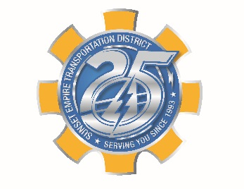
SUNSET EMPIRE TRANSPORTATION DISTRICT
BOARD OF COMMISSIONERS

PUBLIC MEETING NOTICE

SPECIAL BOARD MEETING
JUNE 10, 2019
9:30 AM

Location:
Astoria Transit Center 900 Marine Dr. Astoria OR.

Agenda:

a. Statewide Transportation Improvement Fund Plan Ammendment

Board packs are available at the Astoria Transit Center 900 Marine Drive and Seaside Transit Office 39 N. Holladay
or on line at www.ridethebus.org

Sunset Empire Transportation District operates its programs without regard to race, color, religion, sex, sexual orientation, gender identification, national origin, marital status, age or disability in accordance with Title VI of The Civil Rights Act, ORS Chapter 659A or other applicable law. Alternative formats of this information are available upon request. For more information please contact Mary Parker 503-861-5370 or mary@ridethebus.org

