**Sunset Empire Transportation District**

**BOARD OF COMMISSIONERS**

**SPECIAL BOARD MEETING AGENDA**

**MONDAY JUNE 10, 2019**

**9:30 AM**

**Astoria Transit Center 900 Marine Dr. Astoria, Oregon**

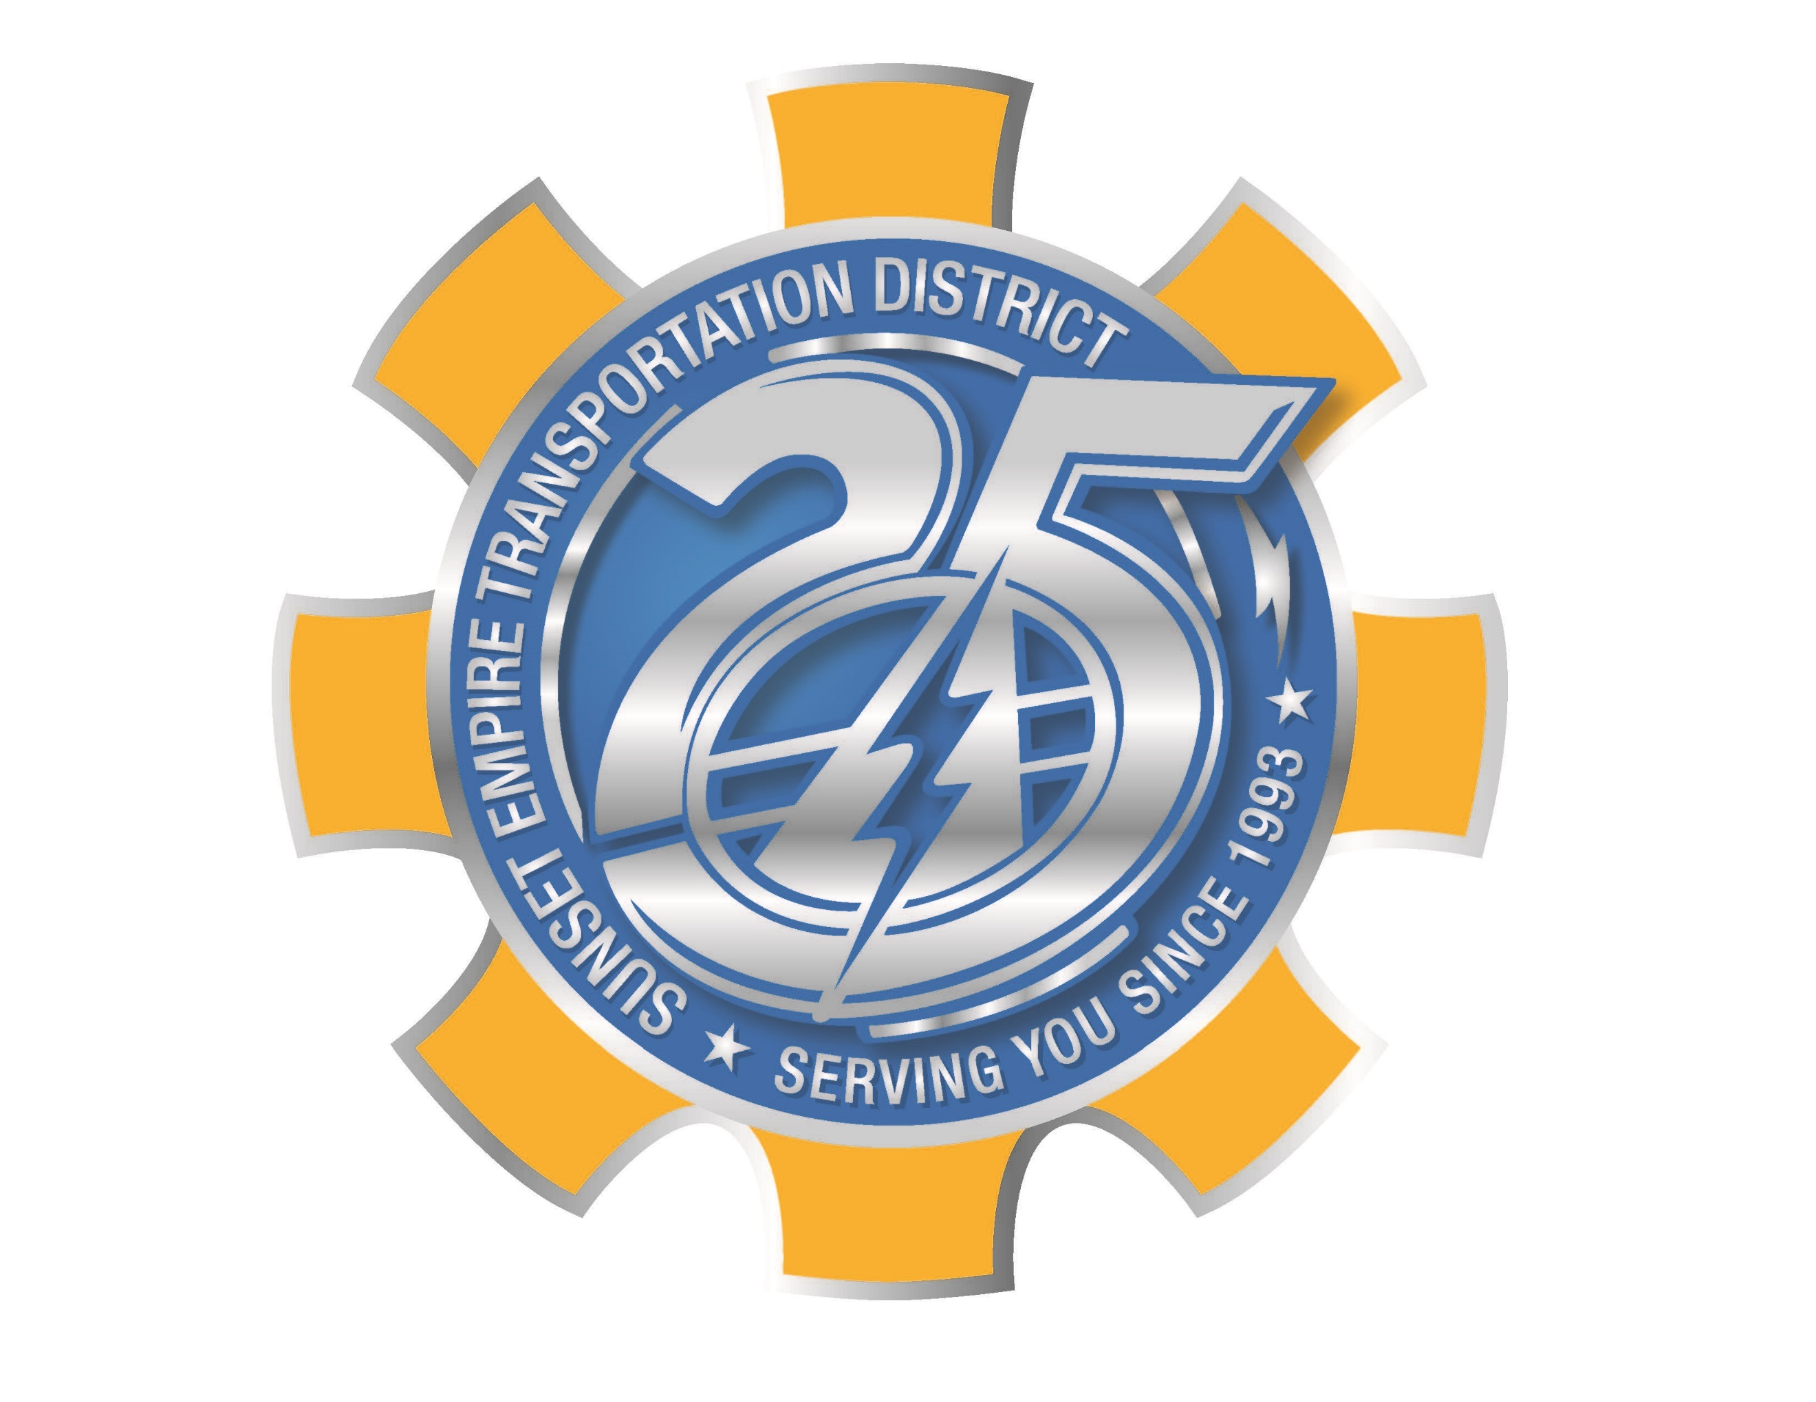

**AGENDA:**

1. CALL TO ORDER; PLEDGE OF ALLEGIANCE
2. ROLL CALL
3. CHANGES TO AGENDA
4. PUBLIC COMMENT (3 minute limit)
5. OLD BUSINESS
   1. STATEWIDE TRANSPORTATION IMPROVEMENT FUND PLAN AMMENDMENT
6. OTHER ITEMS