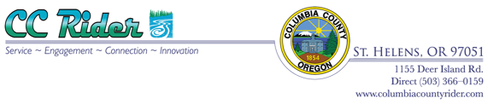

Meeting Agenda
Contacts:
Admin Director - Todd Wood 503-366-8505
Chair - Sharon Evinger: 503-543-8145
DATE: Tuesday, October 16,2018
TIME: 6:30pm – 8:30pm
LOCATION: CC Rider Transit Center
1155 Deer Island Road
St Helens, OR 97051

Call to Order |  |  | Sharon
Public Comments / introductions (limited to 5 minutes per guest) |  |  | Sharon
Ridership Report |  |  | Todd
Grant Updates |  |  | Todd/John
Old Business
1. | Approval of September 18, 2018 Minutes |  | Sharon
2. | Staffing update / Angela / MTR |  | Todd
3. | Laws & Advisory update |  | Todd
4. | Children’s Fair |  | Sharon
New Business
7. | KOHI |  | Sharon
8. | NW Connector Website |  | Sharon
9. | Public Outreach |  | Sharon
10. | Volunteer for input |  | Sharon
11. | New Brochure |  | Sharon
12. | Vote for positions |  | Sharon
STIF New Business
1. | How to use the first round funds |  | Todd
2. | Application deadlines |  | Todd
3. | Vote to send STIF to board of commissioners |  | Sharon
Adjourn – Next Meeting November 20, 2018

Columbia County Citizen Transit Advisory Committee meetings are open to the public.
Accommodations will be provided to persons with disabilities. Please call Todd Wood 503-366-8505, for special arrangements, such as when a sign language interpreter is needed, at least 48 hours prior to the meeting.
*CCCTAC Meetings are recorded. Public Records Requests can be made through the County Commissioners Office.

